This $1 Amish Mix Grows 100-Lb Tomato Plants, Fertilizer Companies Don't Want You to Know

https://youtu.be/PwHqNfDWrjk

Mix
1 4 lb box of organic bone meal – enough for 16 tomato plants – sprinkled in the hole and around the base

Half a cup of crushed egg shells – the egg shells must be ground into a fine powder – fine like flour.
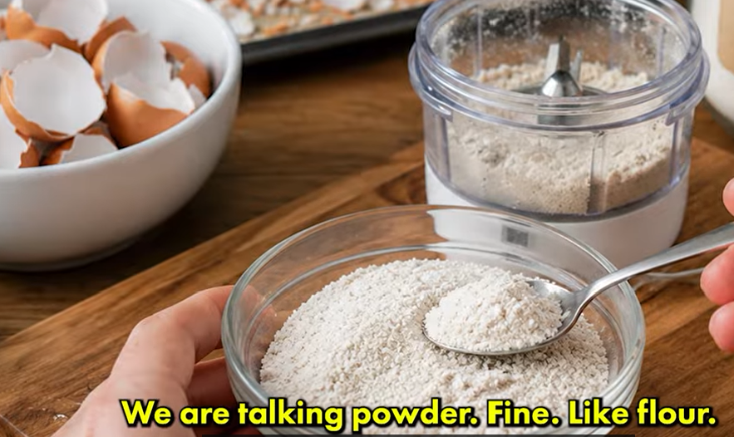

1-2 tablespoons of agricultural lime – organic garden lime





Lime


Two warnings:


After this if you still have bottom rot then your problem is not calcium but water


Even if you mix this perfectly


When you plant you need to dig a hole bigger than the plant in the container so that the roots have room to grow.

Two to three days before planting strip the lower leaves off your seedlings. Leave only the top three sets of leaves. Let those small wounds dry and seal before planting.
 6 – 8 inches deep – not a round hole – a trench and pour your mixture at the bottom. Cover it with two inches of plain soil so that the roots do not touch the mix directly.
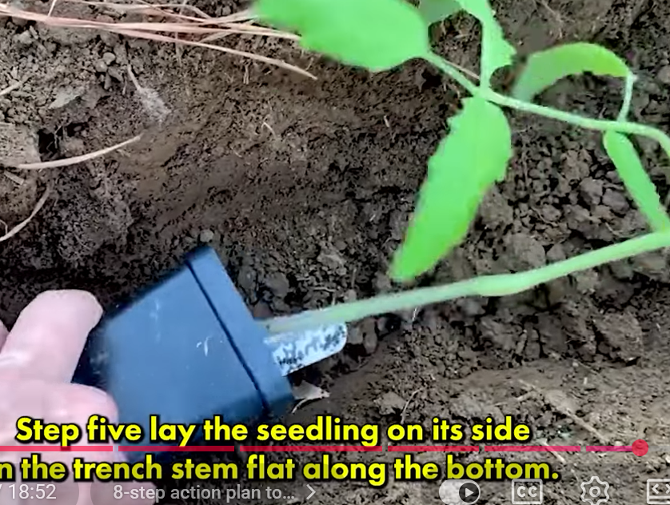
Stem only along the bottom only the leafy top bent

Cover with soil and pack it down and water it deeply.

Step 6 – immediately apply 8 inches of straw or sugar can mulch. Keep the mulch about 1 to 2 inches away from the stem itself so the stem stays dry and does not rot

Step 7 – water deep every 2 – 3 days – soak the soil not the leaves
