This Ancient Liquid Revives Dead Soil Instantly - No Fertilizer Needed!
https://www.youtube.com/watch?v=0pehz0j_lYE

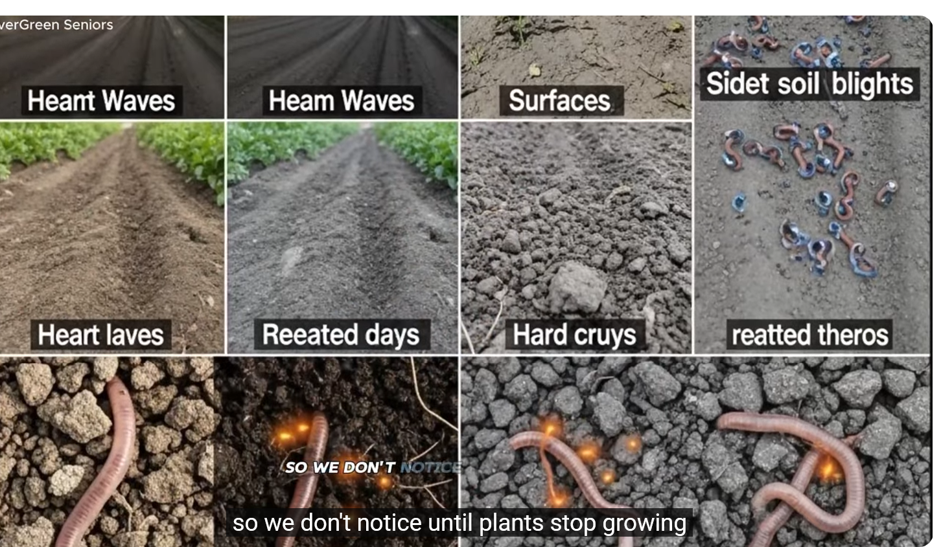

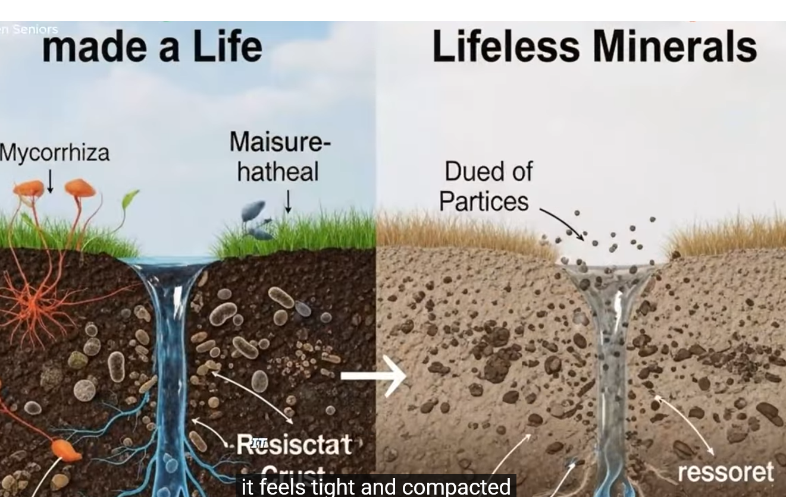
When you cook rice and drain – retain the water. This milky liquid is one of the soils best providers of nutrients To make the rice wash correctly
Don’t put a lid on it – cover it with a breathable cloth 1 cup uncooked rice and 2 cups of clean water. Put the rice and water into a jar and swirl vigorously not gently. You want the water to turn opaque, milky and creamy looking. This is releasing starch. When covered with a cloth the fermentation will be clean and safe. Place jar in a cool place for 2-3 days. No direct sunlight. It starts to separate and the smell will tell you. If the rice wash develops a slightly sour aroma something similar to yoghurt, sour dough or a jar of pickles that means the good microbes have taken over. If it smells rotten, sulfurous or foul toss it out and start again. When your rice water is ready store it in the fridge if you need to keep it longer but try to use it within a week. Before applying dilute it with a ratio of one part and 10 parts water. Water round your plants and do not spray the leaves.

