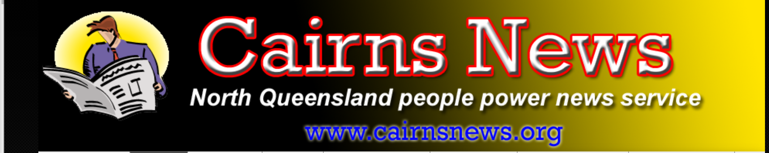

https://cairnsnews.org/2026/04/22/oxford-uk-council-demands-residents-get-permission-to-travel-in-their-city/
Oxford UK council demands residents get permission to travel in their city

Bycairnsnews
Apr 22, 2026 #15-minute cities, #Oxford
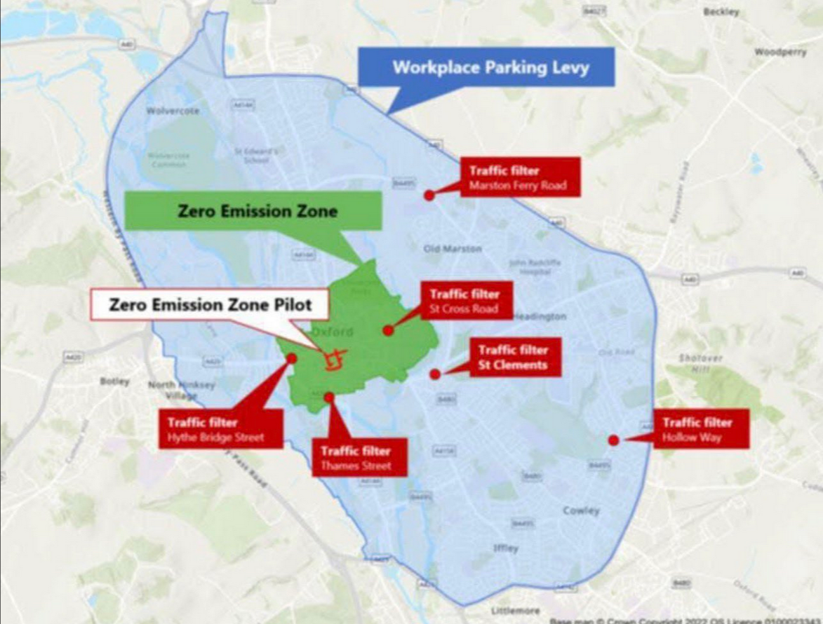The map shows various low-emission zones and a series of so-called traffic filters designed to limit and control traffic movement.
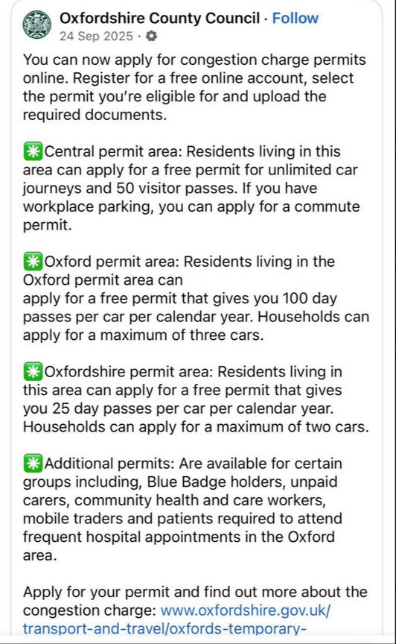

The initial template for your “global” 15-minute city 1.0 before governments start to get really nasty about “zero emissions”..

WITH Oxford, UK being named as the first ever official 15 Minute City, government planners, media and academics are trying to tell us they are not about people control but all about making “people friendly” cities.
No, you don’t have to get permission to leave home, as the fact-checkers insist. Technically that is correct, it’s you just that Oxford residents, for instance, have to have council permission to use certain roads for a set number of times every year, otherwise you will be instantly fined.

In Oxford, and a growing list of other council areas, there is no longer absolute freedom to travel when are where you want. Your movement requires permission being given by government authorities. And of course, it’s all for the cause of zero emissions.

If you live in the main Oxford city area, your access to the city is limited to 100 day passes a year, and for those outside that area a mere 25 days of vehicle access through congestion zones. On remaining days you are forced to use public transport, ride a bike or ride with someone else.

The so-called congestion charge permits require a free online account with the local council, which obviously provides the council a vast new database of private vehicles and when and where their owners travel.

If you park your car at work, you apply for a commute permit. “We allow you to commute to your work,” the council says in effect. But of course, all this talk of totalitarian control is “conspiracy theory”, the media will tell you.

In Oxford the zones have already been drawn up, roads closed off and barriers installed. AI driver surveillance cameras are up and residents have already been asked to apply for their permits that in effect allow them to leave their zone.

All vehicles are of course tracked by the camera network. Go over your quota and you’re fined automatically. PM Starmer and his Labour Party rabble want this system imposed nationwide because they are hellbent on social engineering.

But the 15 minute city is just the tip of the iceberg. The grand plan is contained in the ARUP/C40 report, which is a hellscape of people and resources control and social engineering based on zero-emission ideology.

As reported by Cairns News and other publications in recent years, their Agenda 2030 “vision” includes zero private vehicle ownership, zero meat or dairy consumption, just three clothing items per year, one short-haul flight every three years and 2500 calories of state-approved bioengineered food.

All of this is tied to digital ID and programmable money that controls what you buy, where you go, and how you live. It’s a truly dystopian, Orwellian nightmare. Oh but no, says a journalist writing for an Architectural magazine: It’s really all about people happily strolling or riding bikes in car-free shopping streets, and having everything they need within a 15 minute commute.
As stated by @zeeemedia this isn’t about traffic, it’s about turning cities into open-air prisons. “See how it works—and how close we really are. Watch a full breakdown before it’s too late,” says Maria Zeee.

The totalitarian plan is also outlined by the website of the weasely Islamic Fabian Mayor of London, Sadiq Kahn. Surprise, surprise, it’s all about “the transition to net zero”.

Readers who feel led to comment on this plan can send comments to future.neighbourhoods@london.gov.uk It’s unlikely the little Muslim dictator’s staff will even read the emails, because this entire scheme of control is based on Fabian-style gradualism, deception and lies.
Municipalities in the US are also involved in this World Economic Forum-inspired and UN-driven scheme through ICLEI – Local Governments for Sustainability (originally International Council for Local Environmental Initiatives.

According to a debate contributor on X, zoning for such cities is all over metro Atlanta. “They’ve been building out communities that resemble 15 minute cities for the last decade here. Flock cameras are going up everywhere.

“They’ve built communities that are home to medical centers, dentists, at least one grocer, gas station, a few fast food restaurants, a coffee spot either DD or Starbucks. We’re just waiting for it to begin here in GA. As for the people who believe the globalists are losing, you’re not paying attention.”

Sadiq Kahn’s official explanation for his £7.7 million “Future Neighbourhoods” program is that it will “tackle some of London’s defining environmental challenges, including the climate emergency and toxic air quality, while creating jobs, developing skills and supporting a just transition to a low-carbon circular economy.” Don’t laugh, he’s serious.

“There are 12 Future Neighbourhoods. They are located in some of London’s disadvantaged and climate-vulnerable areas, or where residents are likely to have been severely impacted by the pandemic.” No, he really does believe this baloney.

“Somers Town in Camden and Notting Dale in Kensington and Chelsea have received funding to develop strategies and work with residents to deliver a wide range of innovative and pioneering projects. These projects have been developed with the local community and will bring the benefits of transitioning to net zero to residents.”

The baloney goes on: “C40’s Transforming Cities Series featured Somers Town, hearing directly from local people about the initiatives they have led that have empowered them to build community, resilience and a fair transition to a greener community.

“Ten other Future Neighbourhoods received funding to develop visionary strategies and plans to reach net zero by 2030. These strategies have been created with local communities and provide a clear pathway to a net zero future for neighbourhoods across London.”

Share Everywhere

