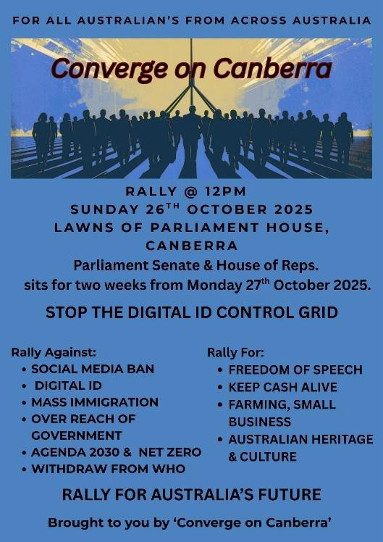
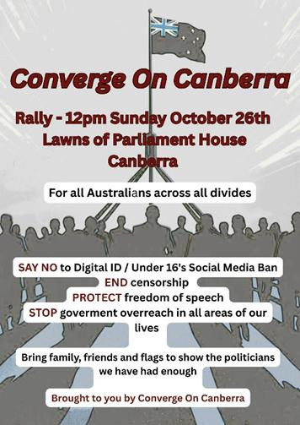
Freedom of Truth news 16/10/25
Canberra Rally against Digital ID

This rally is for..
All Australians across all political, social & racial, divides..

We are a united voice and are giving a clear message to the government that
"we the people" are sick of the way our country is being run and are not going to
comply with the draconian Digital ID control grid being forced upon us that will
enslave people like never before.. (with a Chinese style social credit system and
programable CBDC digital currency)
We support freedom of speech & thought NOT censorship and draconian
control..
We are sick of the government overreach and dysfunction...

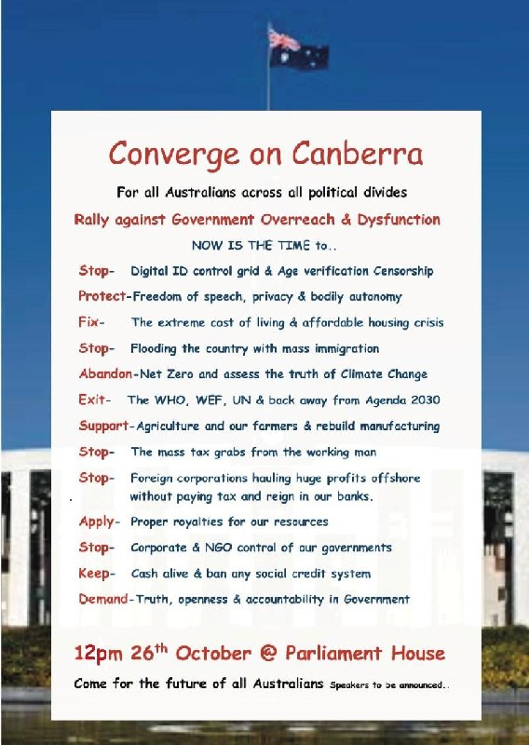
We see the bigger picture behind all of this and are not going to comply to
government policies that are against the peoples best interests.
We are Australians and have our God given inalienable rights and are not
beholden to foreign corporate control..
We recognize our government is not representing us the people but are
following non-government, non-elected globalist interests
Enough is Enough!
We are coming as one to make it clear we want our country back!

