The SCIF: The Clinton
Global Initiative was
Started by Epstein and
Maxwell
By TerraZetzz -
Sunday, 24 August 2025, 0:36 AM
0
33
The SCIF
@TheIntelSCIF
CLINTON GLOBAL INITIATIVE started by
Epstein and Maxwell, confirmed through
Maxwell’s own DOJ interview.
“I was part of the beginning process of the
Clinton Global Initiative. And that was
something that I helped with and that was me,
and Epstein may have helped me help them.” –
Maxwell

She then goes on to say that they came up with
the idea on the way to Davos with a former
president.
Epstein’s own lawyer also stated that, “Mr.
Epstein was part of the original group that
conceived the Clinton Global Initiative.”
The Clintons are tied to USAID, Epstein is
connected to the Clintons in multiple ways. Was
Epstein also directly involved with USAID?
Is this why the Trump administration is having
such a difficult time getting into the USAID
files?
Is this the intelligence connection to the CIA,
Mossad, the Clintons, Epstein, and multiple
fronts and NGOs, along with massive amounts
of money laundering and human t*********g
through multiple different countries, etc.?
These are the questions you need to be asking
yourself and thinking about. Remember, layers,
optics, and timing.

This is so much bigger and darker than you
could ever imagine. How deep does this really
go and who is really all involved? I believe we
all already know the answer…
The writing is on the wall. There are no
coincidences.
Maxwell interview transcript documents & audio
files: https://justice.gov/maxwell-interview
Source: @RealAmVoice @MikeBenzCyber

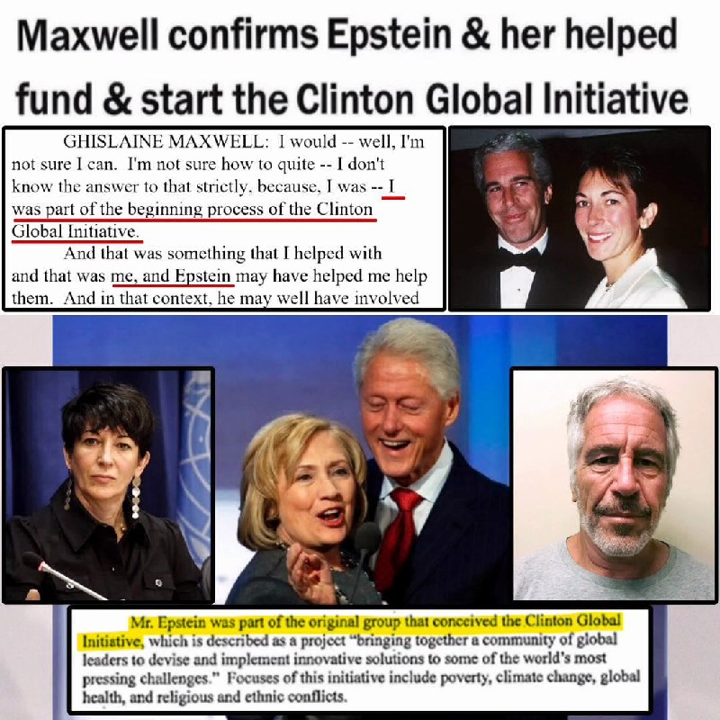
Watch on X

Source(s):
https://x.com/TheIntelSCIF/status/
1959036587443974476

