**Clandestine: Can we Take a**

**Moment to Appreciate How**

**Good we have it?**

By **TerraZetzz** -

Tuesday, 19 August 2025, 22:48 PM

0

172

**Clandestine**

@WarClandestine

Can we take a moment to appreciate how good

we have it?

Not that long ago, we had a walking vegetable

as President, and under his watch, the world fell

into chaos.

Now we have an ACTUAL President, and he is

cleaning up the mess Biden and the Dems

made.

The contrast is clear.

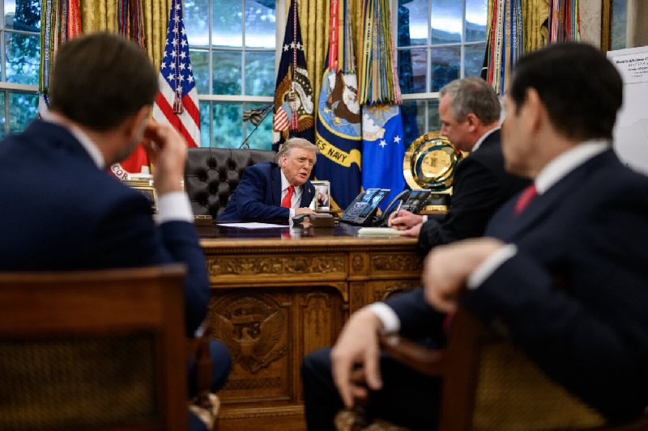

The Dems/MSM spent the last 10 years telling

us Trump was literally Hitler.

In reality, he ended up being the best President

since Washington and is bringing world peace…

This cannot be forgiven. You can’t be wrong

about something of this magnitude.

How can we ever trust the Dems/MSM about

anything ever again? They devoted their lives to

stopping the guy who ended up being one of

the greatest leaders in world history. They tried

to give us Kamala instead of peace, security,

and prosperity.

This cannot be ignored. There must be a great

reckoning for those who tried to prevent the

Golden Age, otherwise the cycle is doomed to

continue.

Heads must roll and the Democrats can never

be allowed anywhere near power ever again.

They have proven that they are not only unfit to

govern, but are an active threat to the

American People and the US Constitution.

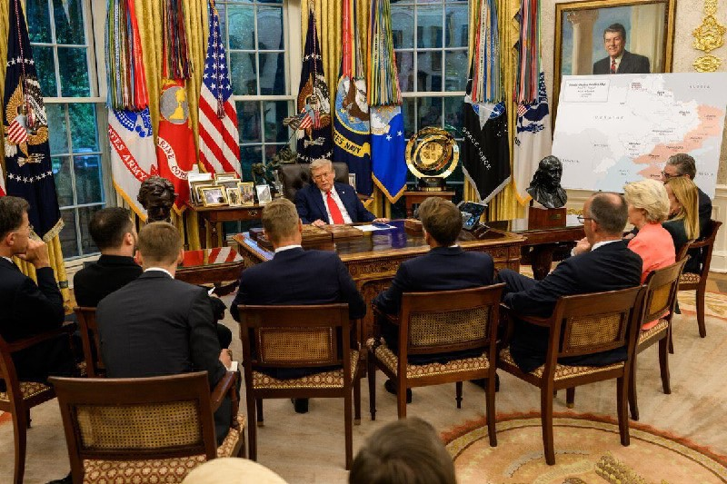

Source(s):

https://x.com/WarClandestine/status/

1957819523874087246

https://x.com/WarClandestine/status/

1957966122650607636