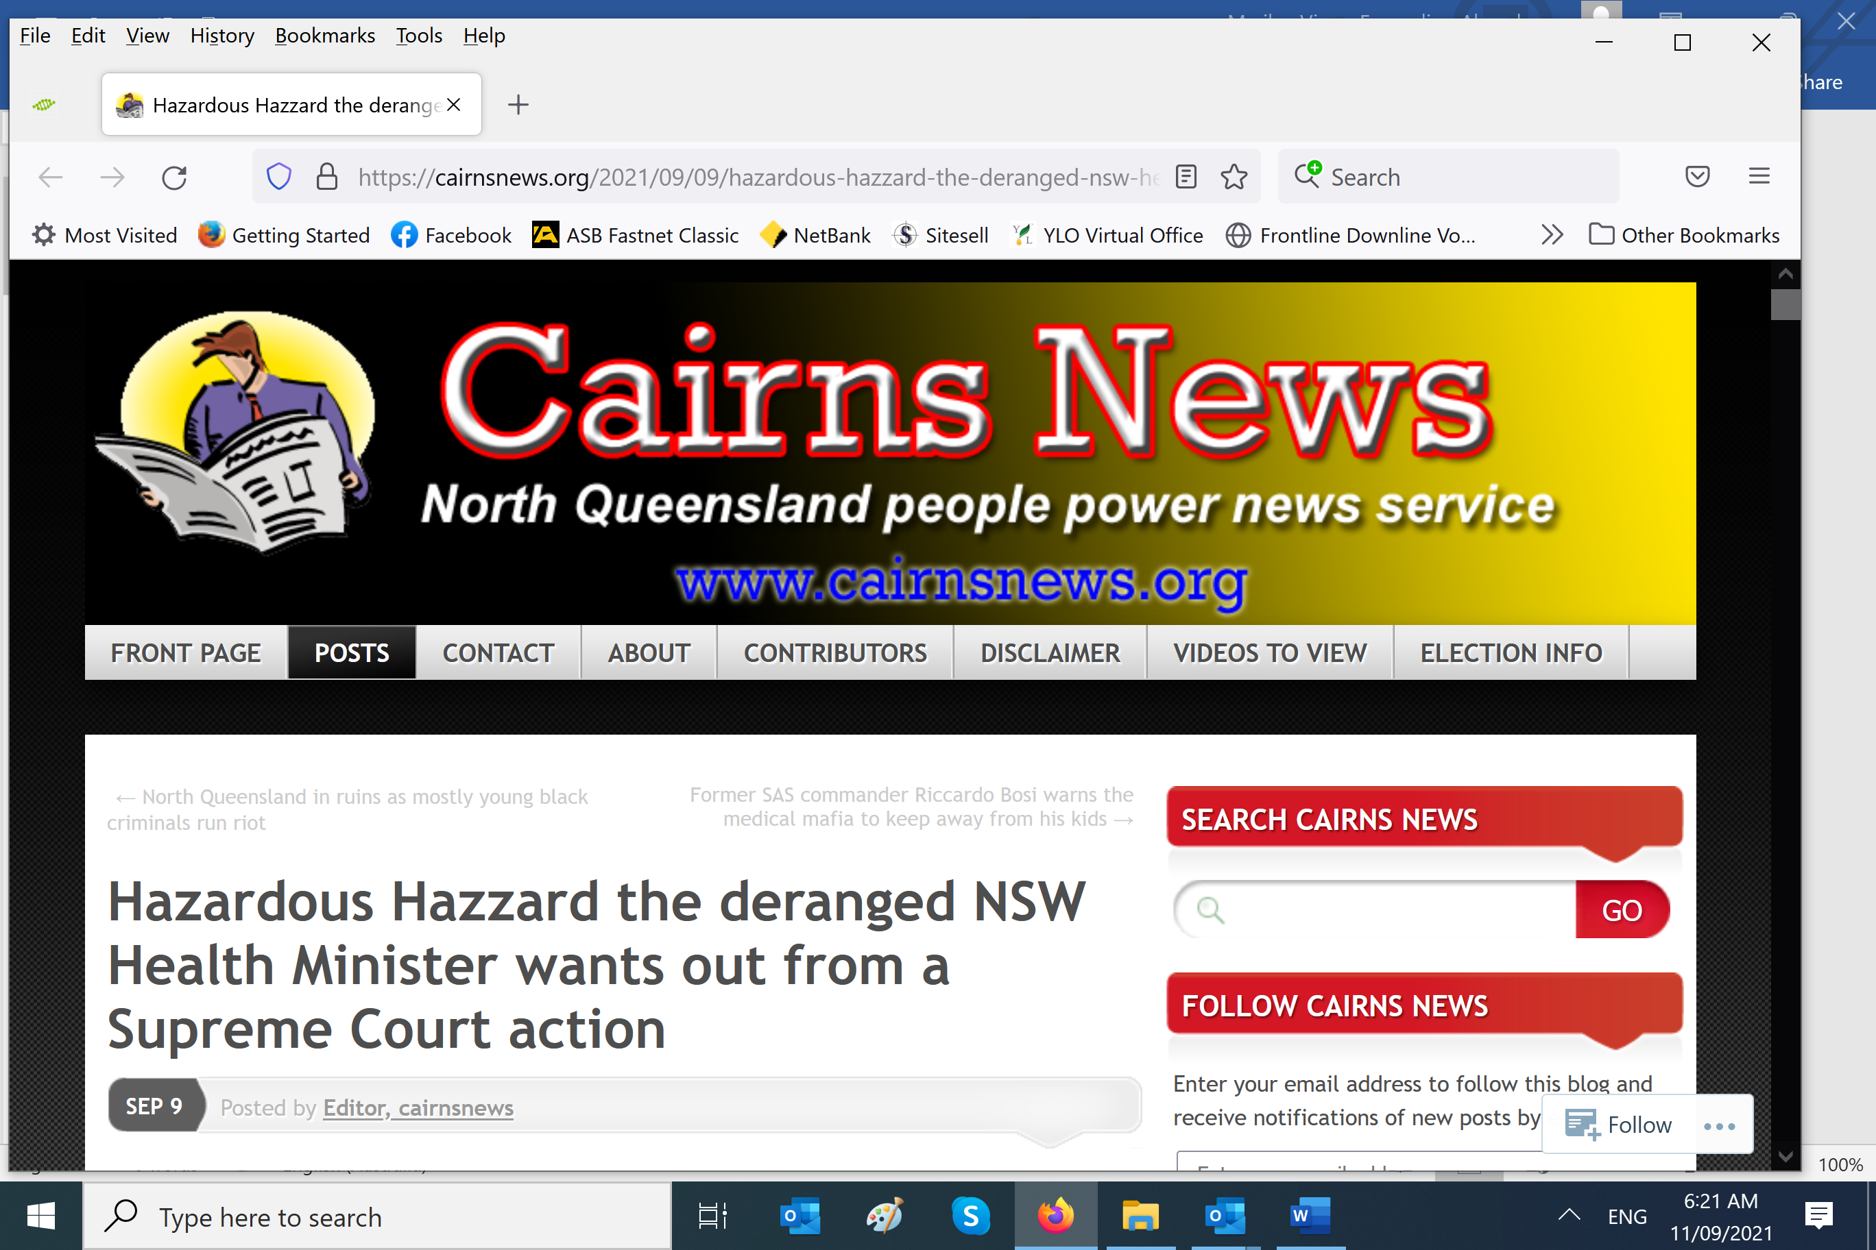

[**https://cairnsnews.org/2025/08/28/vicpol-chief-ran-nz-police-during-the-christchurch-massacre-psyop-is-porepunkah-another-operation/**](https://cairnsnews.org/2025/08/28/vicpol-chief-ran-nz-police-during-the-christchurch-massacre-psyop-is-porepunkah-another-operation/)

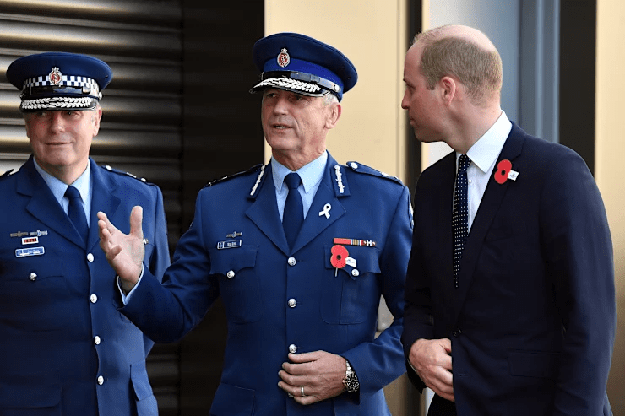28 August 2025

**VicPol chief ran NZ police during the Christchurch massacre psyop: Is Porepunkah another ‘operation’?**

Former New Zealand police chief Mike Bush with Prince William. Bush is now Chief Commissioner of Victoria Police - just the man for special operations against troublesome minorities?

**CHRISTCHURCH INFORMATION FIRST**

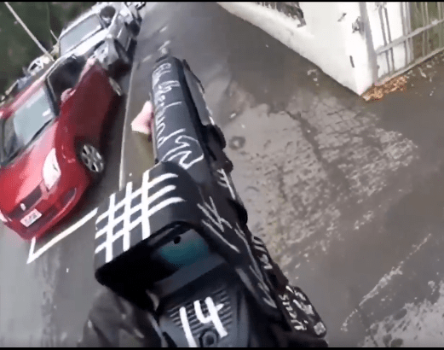 A forensic investigation into the Christchurch massacre video strongly indicates that the weapons (above) are not real firearms, but Airsoft replica rifles (gas powered or electric) for the following reasons:  
• With the orange flash suppressor removed/replaced, they look exactly like a real firearm.  
• The mechanism functions exactly like a real firearm.  
• They have magazines that load BB rounds that look exactly like live rounds.  
• They exhibit a considerably lower recoil action and effect exactly as demonstrated in the video.  
• Strikes on a body and clothing, plus the lack of bodily trauma and damage to surrounding building material, is identical to that which occurs from a BB pellet. They will sting and possibly bruise exposed skin, but will not injure to any great degree unless hitting the face or soft tissue such as the eyes.  
• When fired, they eject cartridge casings exactly like a real spent cartridge of a live round.  
• They have a very similar sound, although obviously not the same as a live round because of the obvious power differential – but a sound track can be edited into a video post-production  
to further the illusion.

******

***By MICHAEL SLOVANOS***  
VICTORIA Police Chief Commissioner Mike Bush might like to explain how a fake terrorist shooting video became the central piece of evidence for the alleged massacre of Moslems in Christchurch, New Zealand, in March, 2019.

We might guess Bush’s answer is “because I can use the evidence I want to, and what you say or think is irrelevant”. Well of course we understand that a person of the Chief Commissioner’s stature who rubs shoulders with British Royalty can basically do whatever he likes.

But we also understand that people of his stature can be bit players in schemes run by even “bigger” entities who like to run certain traumatic events with the objective of socially engineering target populations and pushing through legislation that normally wouldn’t be countenanced.

One such event appeared to be the 2017 Bourke St Mall car attack. James Gargasoulas, the perpetrator, drove his old Holden Commodore in [circles around the Flinders St intersection](https://www.youtube.com/watch?v=mdcfNzXt-GI) while certain individuals in blue, standing around the intersection, arm-signalled him.

And then three unmarked police cars arrived at the scene (see 1min02s mark). They could have easily boxed him in, but instead stopped, then followed Gargasoulas at slow speed to the city centre where he drove unhindered down a crowded footpath and then to the Bourke St Mall and ran people down, killing six.

And lo and behold, sitting having a coffee at the Mall ready to witness the attack was former Chief Commissioner Christine Nixon who defended the [shocking police mishandling](https://www.abc.net.au/news/2018-01-20/former-top-cop-christine-nixon-defends-police-handling-bourke-st/9344800) of the event. And Mrs Nixon now thinks Mr Bush is just the right man to run Victoria Police.

Cairns News, and many other people and organisations, have in their possession a publicly downloadable [forensic analysis and report](https://cairnsnews.org/wp-content/uploads/2025/08/Forensic-Analysis-Update-CHCH-Mosque_1755937735747.pdf) on the live-streamed video of one part of the alleged Christchurch massacre, confirming what many of us suspected was a staged event, a psyop, a type of Hollywood production.

And the fact that Bush and other police played along with this massive act of fraud and deception brings into question the current big event up in North East Victoria, the alleged shooting of two of your fellow police officers by someone who for several years caused a [grea](https://www.facebook.com/cambodianmedia/videos/164828532508077)[t](https://www.facebook.com/cambodianmedia/videos/164828532508077) [deal of trouble](https://www.facebook.com/cambodianmedia/videos/164828532508077) for police and the legal system in the court rooms.

It’s certainly a tragedy for police officers to not come home to their families from a shift, but we’re not going to spin this “good guy cops versus bad guy sovereign citizen” narrative that Bush’s political and media friends are doing so studiously.

We know for a fact that Freeman was not a “sovereign citizen” who, as the Victorian Premier said, “did not believe Australian laws applied to him”. That’s a blatant lie spread by Bush’s police force and repeated by media. A close friend says Freeman knew very well that the term “sovereign citizen” is nonsensical.

We also know, from video evidence available online, that Freeman used and cited Victorian and Australian law in his many court appearances, as the video linked above shows.

Freeman was probably somewhat over-ambitious, unrestrained and even belligerent in his self-represented courtroom appearances, but be believed in his lawful rights and continually cited the law.

We have to ask the question: Was Dezi Freeman the target of a provocative police operation designed to demonize people who stand up to police and establishment bullying and creeping police state authoritarianism?

Or will it be the excuse for a fresh government gun grab as we saw after the Port Arthur operation?

We also wonder if this operation also designed to demonize this weekend’s March for Australia? Judging by the [ABC’s outpouring](https://www.abc.net.au/news/2025-08-28/who-is-behind-march-for-australia-anti-immigration-rallies/105657548) of “anti Nazi”, “anti-far right” and “anti sovereign citizen” propaganda in recent days, it looks very much like the case.