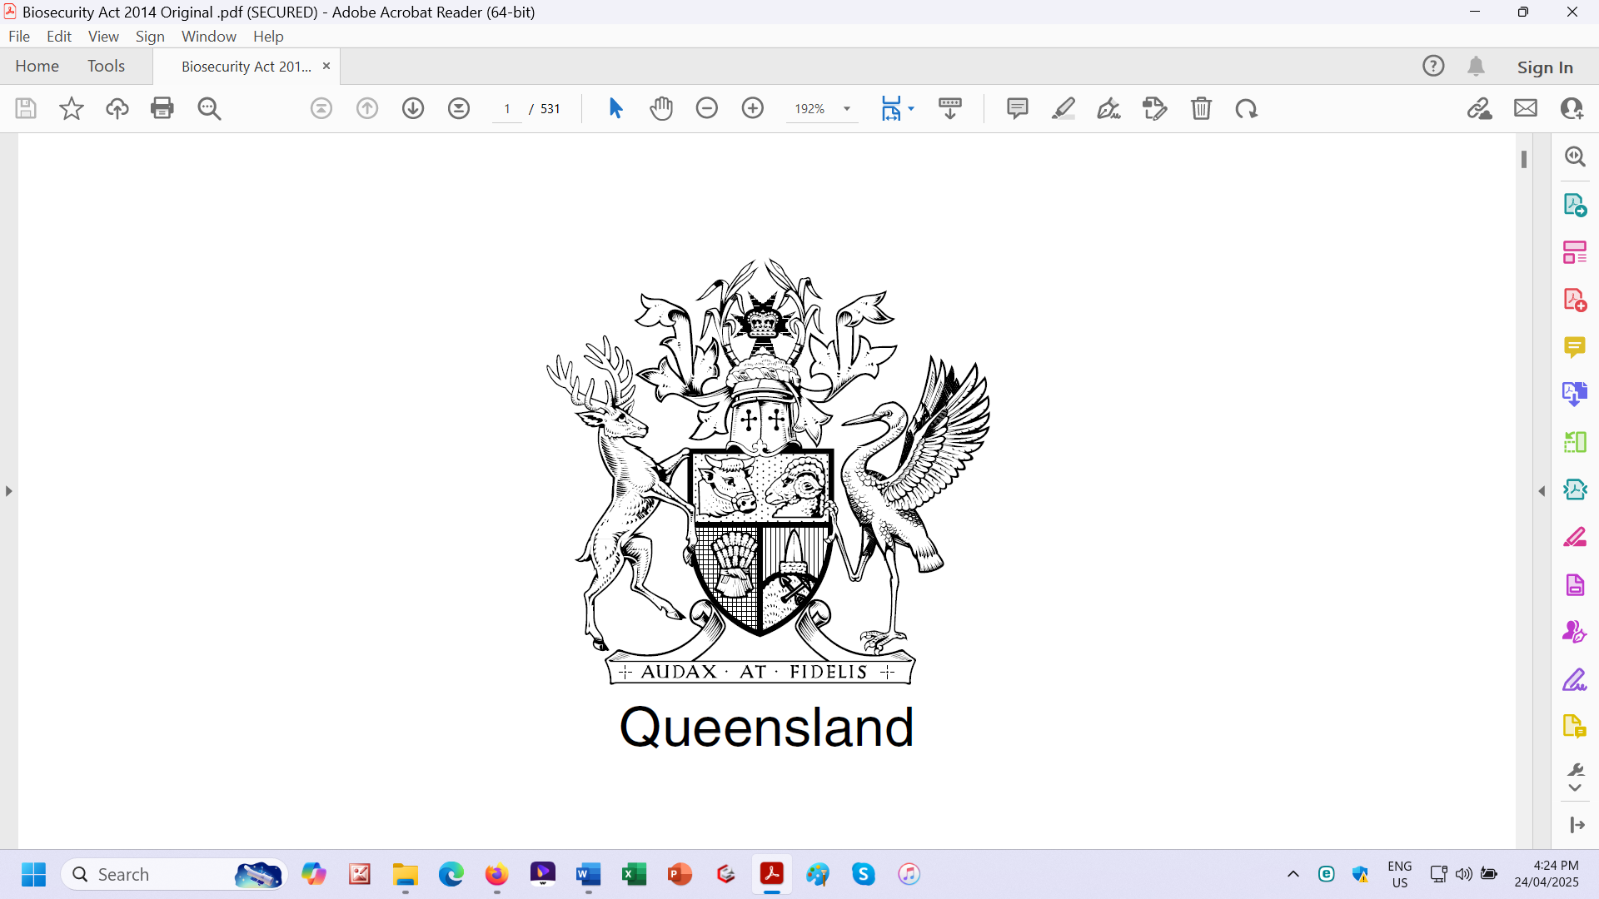

**Total Fraud**

**Biosecurity Act 2014**

**Act No. 7 of 2014**

**The Parliament of Queensland enacts— This Queensland belongs to the Satanic Treasonous Political Parties.**

**2 Commencement**

(1) This Act commences on a day to be fixed by proclamation.

(2) However, if no day has been fixed by 1 July 2016, the Act

commences on that day. **No Crown and Constitutional Authority**

(3) The *Acts Interpretation Act 1954*, section 15DA does not

apply to this Act.

© State of Queensland 2014

Authorised by the Parliamentary Counsel

**You can’t copyright Crown Law.**

This Act has **NO** Crown and Constitutional Authority.

The Satanic Treasonous Political Parties tell you

That these Acts are private Acts.

These Satanic Treasonous Political Parties also

tell you that all *their* so-called Acts after the

Australia Acts are only purported Acts

with purported enactments.

All those so-called Police are only costume wearing paedophile

protecting mercenaries jumping to tune for *their* masters

Satanic Treasonous Political Parties which are not within

Our Primary Law, Commonwealth of Australia Constitution Act 1901

as Proclaimed and Gazetted under the Royal Coat of Arms.