




















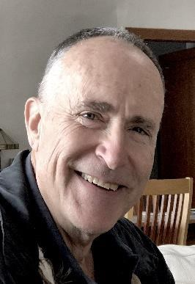



PRESENTS

POPULAR SOVEREIGNTY ENERGY SOVEREIGNTY
including refreshments
and evening entertainment.

1156 Main Arm Road, Main Arm 2482 NSW
email: chris @ znews. tv Ph: 02 6684 5211 landline, no sms

EXPLORE the A series of Adventures – All 9am HUNT FOR THE BEST
welcome, pick one, some ROOT - tumeric, ginger,
FUNNY FARM
or all taro or slang
interpretations
30 acres of organic 9am Hunt for the Lost
Shack – invisible for 20
macadamia nuts 10am START or HELP
years
Free for All the REVOLUTION to
10am Hunt for the Perfect HEAVEN !
300 acres of Woman
Problems on Earth by
natural forest, a 11am Hunt for Inner Peace
Chris Mclrath
few patches
12 noon Hunt for Good
Solutions discussed and
original Health
agreed with a timeframe
2 pm Hunt for Ricardo and participants – teams
2 dams to swim,
Johannson in forest and
boat, sunbake or beyond Noon - LUNCH with folks
exercise gathering in groups of
3pm Hunt for an honest
similar interest
Politician
Various
2pm TIMELINE Agreed:
interesting 4pm Hunt for the evil Ones
Who is doing which
buildings, 5pm Hunting for LOVE in all tasks when and list of
the wrong places materials required for
gardens and
people 6pm Hunt for Good Food each task when
finished...

