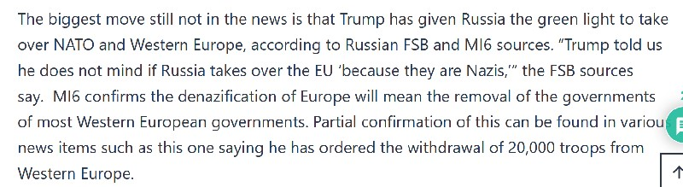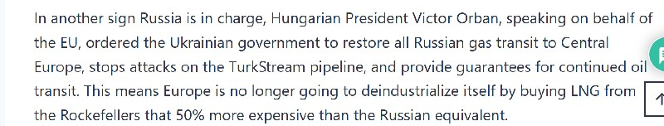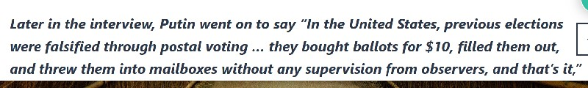
Trump to hand control of Western Europe to Russia as revolution continues
https://benjaminfulford.net/trump-to-hand-control-of-western-europe-to-russia-as-revolution-
continues/
Benjamin Fulford
27 January 2025

The revolution that swept US President Donald Trump into power is unfolding at a blistering rate.
Since a lot of it is all over the news and readers have probably already seen it, we will concentrate
this week on things they may have missed.

https://x.com/defense_civil25/status/1883281354395439141?ref_src=twsrc%5Etfw%7Ctwcamp%5Et
weetembed%7Ctwterm%5E1883281354395439141%7Ctwgr%5E0166d5230cdbef902a6bfe521fe9cf
cbf7fce63a%7Ctwcon%5Es1_&ref_url=https%3A%2F%2Fwww.rumormillnews.com%2Fcgi-
bin%2Fforum.cgi%3Fread%3D250720

Russia’s Tass News Agency for its part reports top military officials of Armenia, Kazakhstan,
Azerbaijan and Ukraine took part in a meeting of the NATO Military Committee in Brussels last
week. Russian FSB sources say these former Soviet countries will join NATO as a precursor to
Russia joining.

https://tass.com/politics/1903295

https://tass.com/economy/1903549

https://halturnerradioshow.com/index.php/news-selections/world-news/putin-if-trumps-2020-win-
wasnt-stolen-thered-be-no-ukraine-war

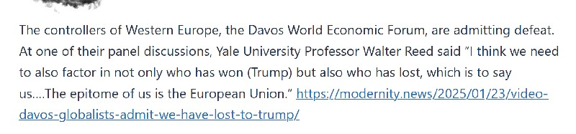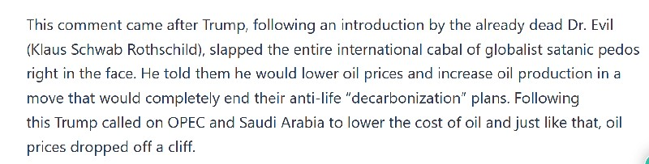
2

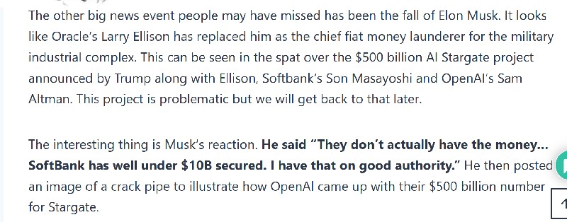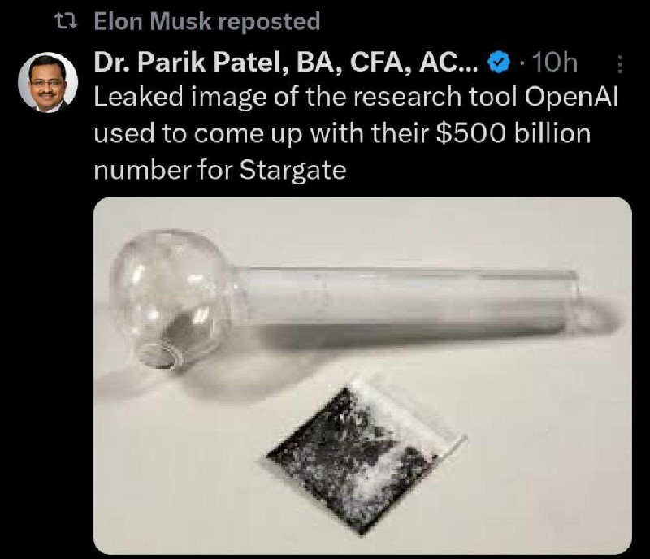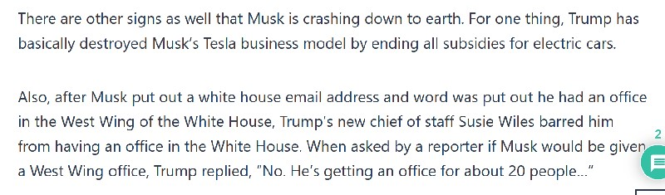
3

https://www.hindustantimes.com/world-news/us-news/donald-trumps-chief-of-staff-denies-elon-
musk-west-wing-access-101737772256562.html

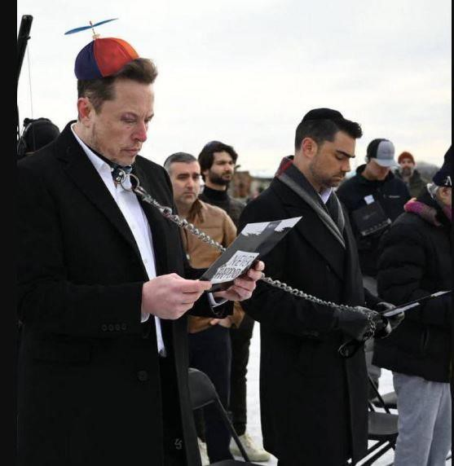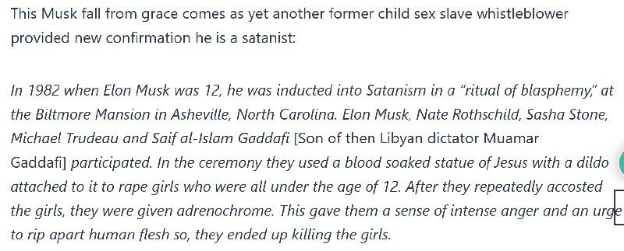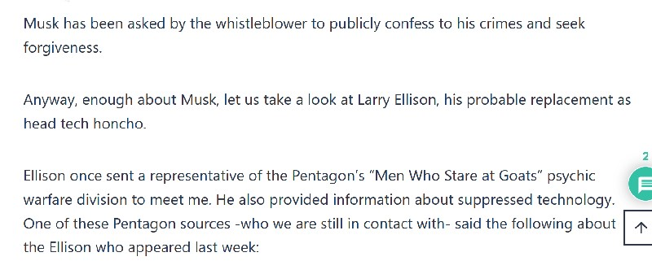
4
Now it turns out Musk has been put in chare of the US Digital Service, which has little to do with
budget cuts. Not only that he reports to Wiles not Trump. This AI generated picture illustrates his
fall.

https://rumble.com/v69wuf4-survivor-testimony-elon-musk-was-at-a-satanic-ritual-like-me-video-
182.html

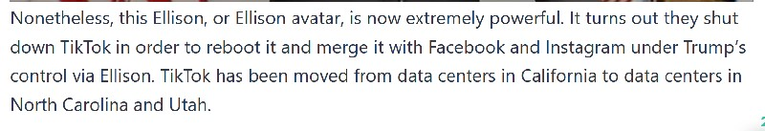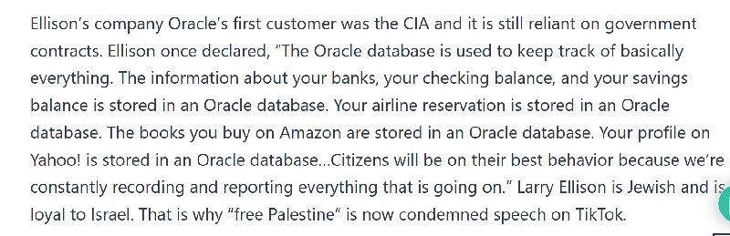
5
“Larry Ellison has had face lifts. Maybe he is part AI already. He has changed 100%”.

Video https://benjaminfulford.net/wp-content/uploads/2025/01/Larry-Ellison-has-changed-
100.mp4?_=1

https://www.tiktok.com/@kaytipie/video/7461766193356033311?_r=1&_t=ZT-8tOnyqR9F2E

https://www.tiktok.com/@frogslyn/video/7462383963538001182?_r=1&_t=ZT-8tOvnxTtZTW

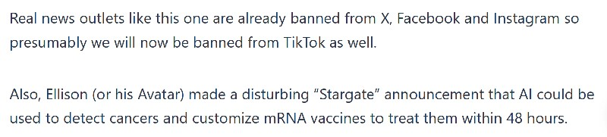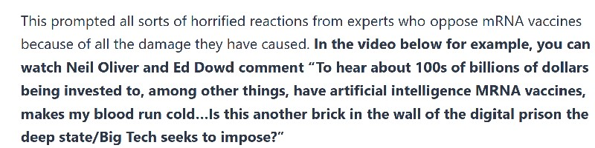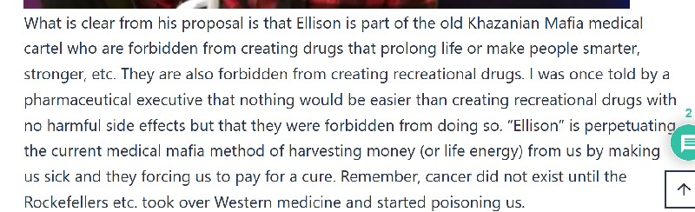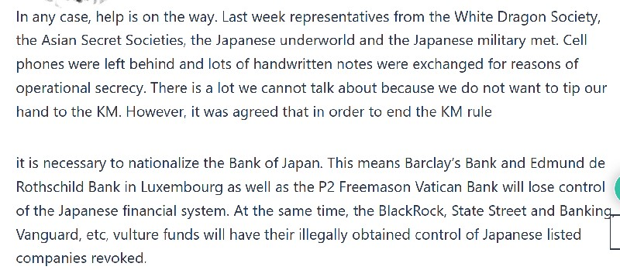
6

https://www.newsweek.com/donald-trump-mrna-vaccine-cure-cancer-ai-2018701

Video https://benjaminfulford.net/wp-content/uploads/2025/01/Neil-Oliver-on-high-alert-after-the-
shocking-Stargate-debacle.mp4?_=2

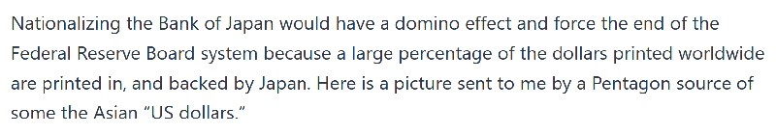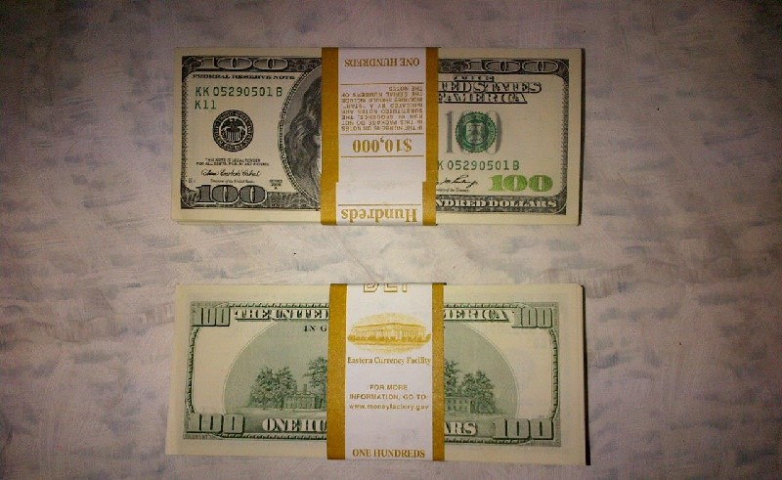
7

The Federal Reserve is a crime pure and simple.

https://x.com/iluminatibot/status/1883069858125881616?ref_src=twsrc%5Etfw%7Ctwcamp%5Etwee
tembed%7Ctwterm%5E1883069858125881616%7Ctwgr%5E171a54b57634fa25e78343cfdd33cd8a
a99a1440%7Ctwcon%5Es1_&ref_url=https%3A%2F%2Fwww.rumormillnews.com%2Fcgi-
bin%2Fforum.cgi%3Fread%3D250679

The Japanese are going to put an end to this crime.

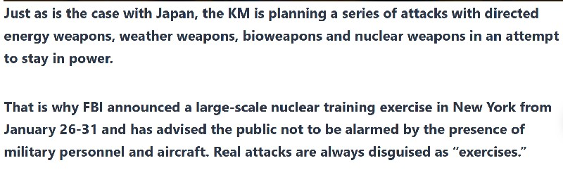
8

Video https://benjaminfulford.net/wp-content/uploads/2025/01/Eva-Vlaardingerbroek-from-The-
Netherlands-shouts-out-to-public.mp4?_=3

https://cbs6albany.com/news/local/agencies-participating-in-large-scale-nuclear-incident-training-
exercise-around-region

The fires in California are a very real example of the sort of attack that can be expected worldwide
until the KM is finally defeated. The videos below show California is still under attack.

Video`https://benjaminfulford.net/wp-content/uploads/2025/01/Download.mp4?_=4

Video https://benjaminfulford.net/wp-content/uploads/2025/01/Hundreds-of-homes-are-under-
immediate-threat-near-Castaic-California-as-the-fire-now-burns-over-5000-acres.-.mp4?_=5

Trump knows the fires were an attack saying: “It looks like something hit it. And we won’t talk about
what hit it”.

Video https://benjaminfulford.net/wp-content/uploads/2025/01/Trump-on-the-CA-fires-It-looks-like-
something-hit-it.mp4?_=6

The KM also hit Florida with what was almost certainly a weather warfare attack. Florida had a
bigger single-day snowfall than nearly every major Canadian city – even the north.

Video https://benjaminfulford.net/wp-content/uploads/2025/01/Welcome-to-Florida-The-Sunshine-
State-Meanwhile-in-Davos-all-the-attention-of-the-powers-that-be-is-focused-on-Global-
Warming.mp4?_=7

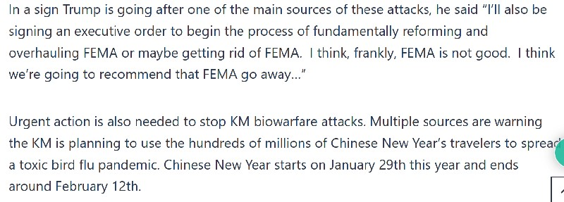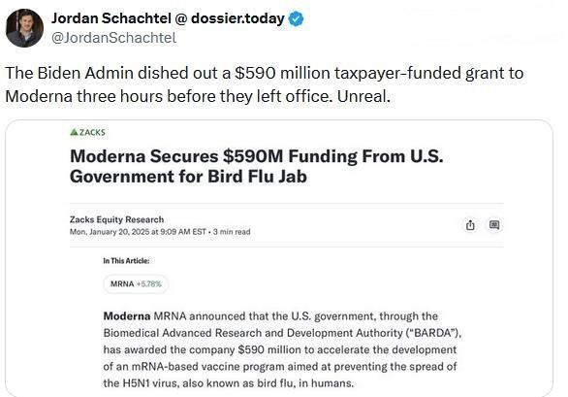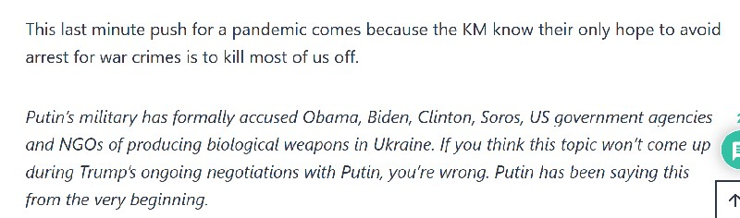
9
Video https://benjaminfulford.net/wp-content/uploads/2025/01/Florida-had-a-bigger-single-day-
snowfall-than-nearly-every-major-Canadian-city.mp4?_=8

In what may have been last-minute financing for biowarfare, the Biden Admin dished out a
$50 million taxpayer-funded grant to Moderna three hours before they left office.

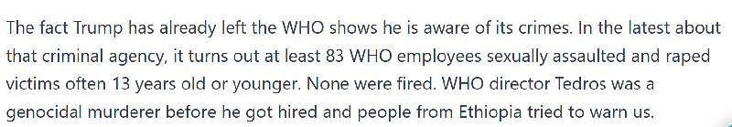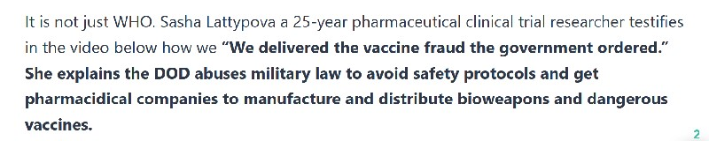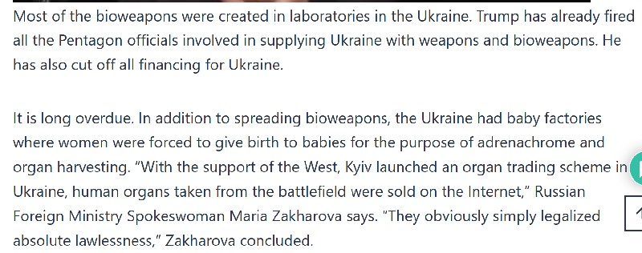
10
https://x.com/WarClandestine/status/1881483437296566452

https://x.com/WarClandestine/status/1881483437296566452

https://celiafarber.substack.com/p/who-rape-scandal-at-least-83-
staff?publication_id=257742&r=1mipqn

Video https://benjaminfulford.net/wp-content/uploads/2025/01/We-delivered-the-fraud-the-
government-ordered.mp4?_=9

https://tass.com/politics/1903487

Video https://benjaminfulford.net/wp-content/uploads/2025/01/Zelensky-is-panicking.mp4?_=10

Don Trump Jr says Zelenski begged for an invitation to inauguration 3 TIMES – and then pretended
that he didn’t want to go, once he was turned down repeatedly.

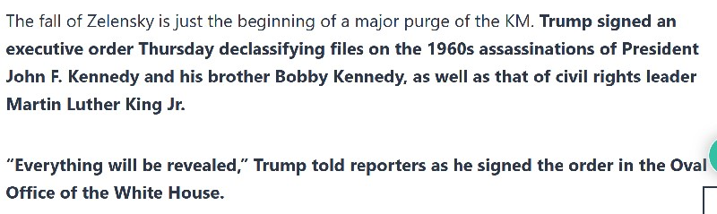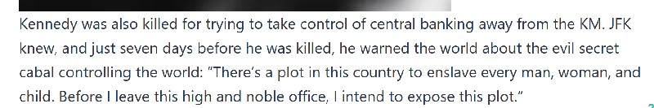
11
https://x.com/RT.com/status/1880751148736610589

https://insiderpaper.com/trump-signs-order-to-declassify-jfk-rfk-martin-luther-king-jr-files/

Video https://benjaminfulford.net/wp-content/uploads/2025/01/The-Zionist-Mossad-killed-
JFK.mp4?_=11

https://benjaminfulford.net/wp-content/uploads/2025/01/He-knew.-He-warned-us.-They-silenced-
him.jpg

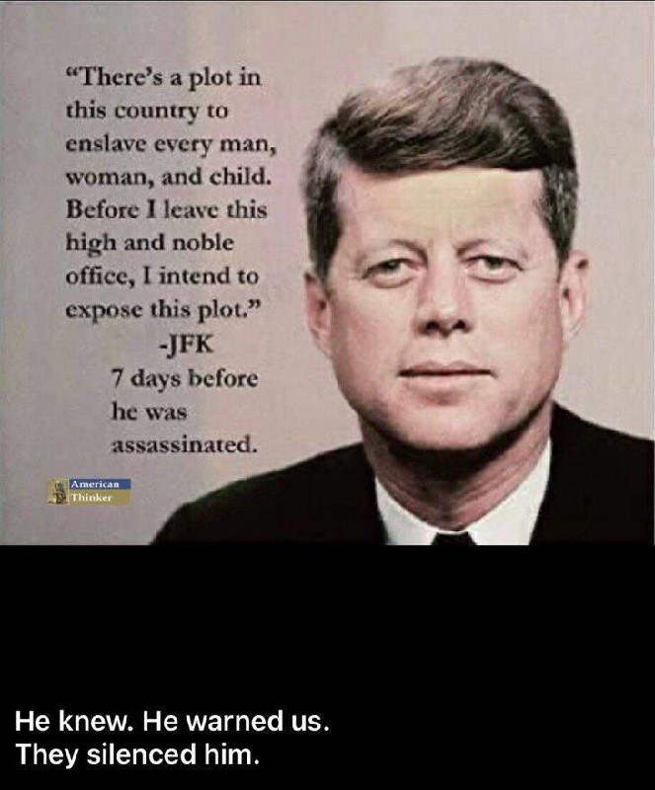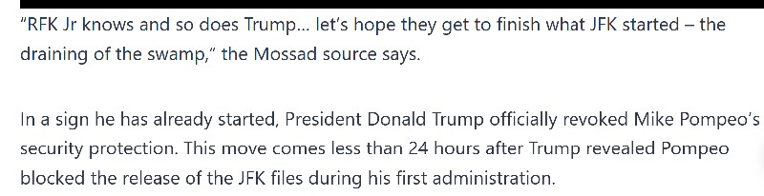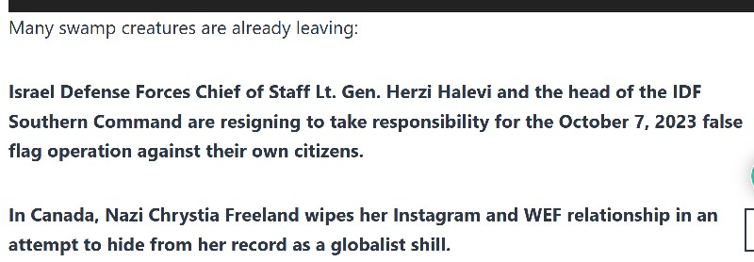
12

Video https://benjaminfulford.net/wp-content/uploads/2025/01/Exposing-the-cabal-.mp4?_=12

Video https://benjaminfulford.net/wp-content/uploads/2025/01/A-good-reason-to-cancel-Pomepos-
security-clearance-.mp4?_=13

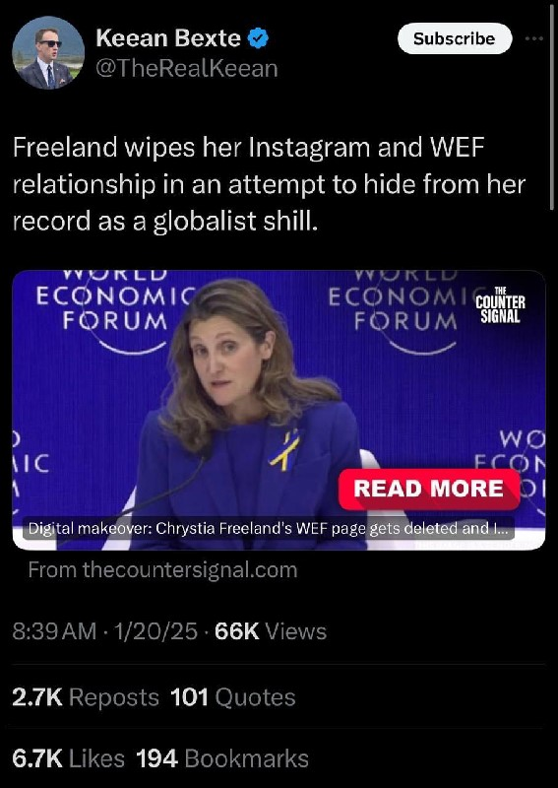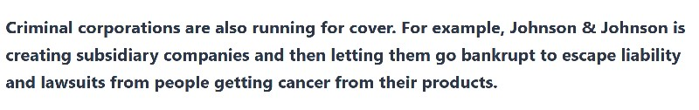
13

Video https://benjaminfulford.net/wp-content/uploads/2025/01/Johnson-and-Johnson-try-to-hide-
assets-.mp4?_=14

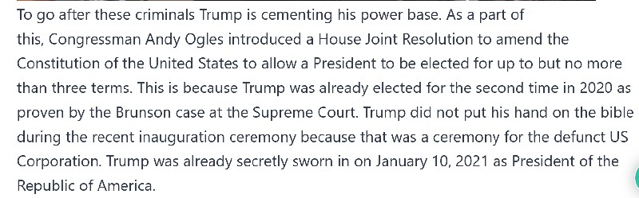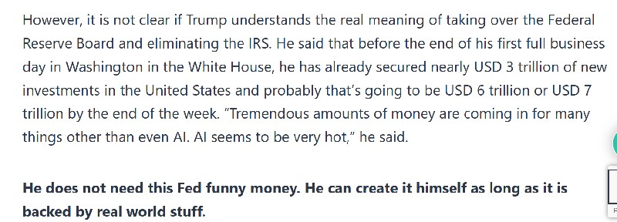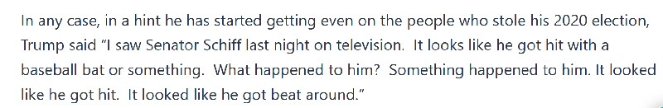
14

Video https://benjaminfulford.net/wp-content/uploads/2025/01/Trump-did-not-put-his-hand-on-the-
Bible-.mp4?_=15

Video https://benjaminfulford.net/wp-content/uploads/2025/01/Trump-No-hand-on-the-Bible-
%E2%80%A6.mp4?_=16

As evidence Trump is now going after the Federal Reserve board, he said “You know [the IRS] hired
– tried to hire – 88,000 new workers to go after you, and we’re in the process of developing a plan to
either terminate all of them or maybe we’ll move them to the border.”

https://www.msn.com/en-in/news/world/us-president-donald-trump-announces-500-billion-ai-
initiative/ar-AA1xCZxG?ocid=BingNewsSerp

https://www.whitehouse.gov/news/page/2/

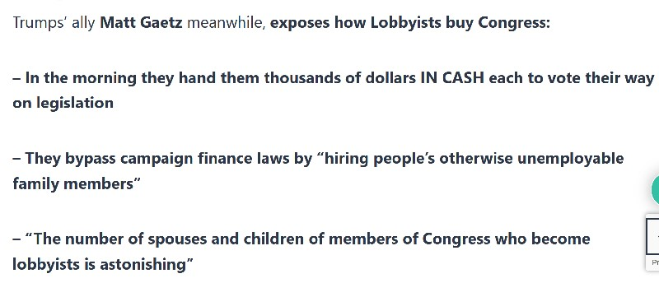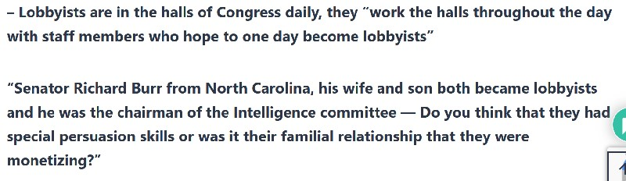
15

Video https://benjaminfulford.net/wp-content/uploads/2025/01/Matt-Gaetz-on-how-the-lobbyists-
work.mp4?_=17

This is in addition to them being forced to be filmed carrying out sexual crimes against children as a
condition for taking public office.

Trump is also taking action to end crimes against children. They found 80,000 kids in four days. It is
a good bet they wee in the tunnels underneath LA. Let’s see if he now releases the Epstein files.

https://x.com/StephanieStarrC/status/1883221360505413919?mx=2

As evidence this might happen, the new administration provides detailed information about the
trafficking of children and what is being done about it.

https://www.state.gov/policy-issues/human-trafficking-crime-human-trafficking-and-illicit-activities/

Trump is also making moves to exert control over the entire American Continent. In the video below
Trump hints at taking over Greenland and Canada by saying “get ready for an enlarged America.

Video https://benjaminfulford.net/wp-content/uploads/2025/01/Get-ready-for-an-Enlarged-America-
.mp4?_=18

He also asserted control by jerking Columbia’s chain when they tried to refuse to take in deported
illegal Columbian immigrants.

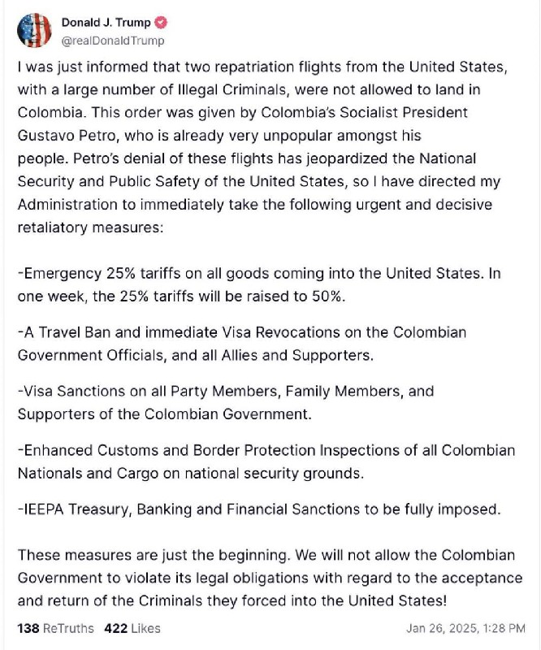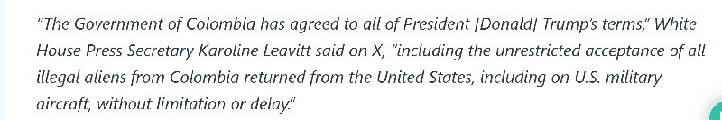
16

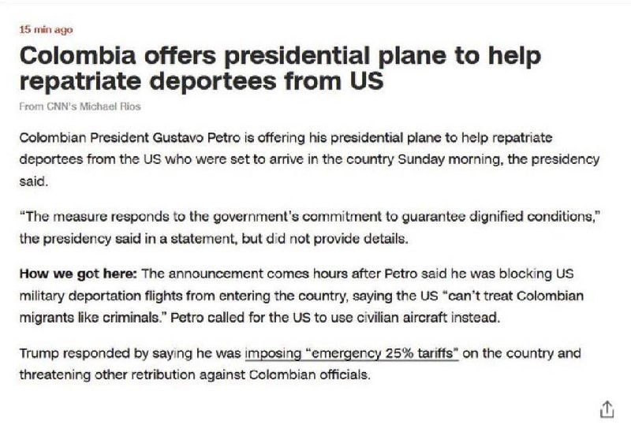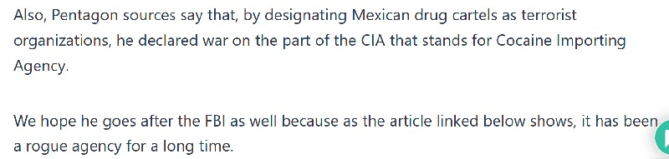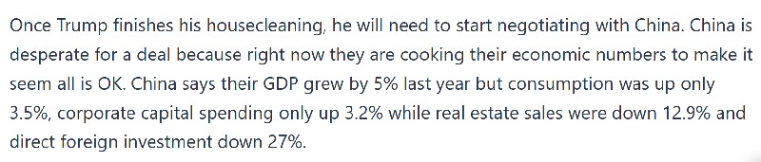
17

https://fee.org/articles/8-historic-cases-that-show-the-fbi-and-cia-were-out-of-control-long-before-
russiagate/

https://news.yahoo.co.jp/articles/d509e8e144e69a98a4ad5b11270b41efbf3a3489?page=3

Also Trump needs to reach a deal with China over AI.

Imagine we’re back in 2017 and the iPhone X had just been released. It was priced at $999.
Apple was crushing sales and building a wide moat arounds its ecosystem.

18
Now imagine that a few days later another company introduced a phone and platform that
was equal or better in every way and cost only $30.

That’s what happened today in the AI space. China’s DeepSeek released an open-source
model that works just as well as OpenAI’s latest models, but costs a fraction of the price.
What’s more you can even download it and use if for free (except for the cost of your
electricity).

https://id.nl/huis-en-entertainment/huishouden/wassen-en-drogen/waar-moet-je-op-letten-bij-
het-kopen-van-een-strijkijzer

Finally this week, in a sign we are headed for extraordinary events, I detected 9 bright celestial
objects in the sky last night. P3 Freemason sources say one of these is an unknown object of
immense proportions and sent us this video as evidence.

Video https://benjaminfulford.net/wp-content/uploads/2025/01/sky-object.mp4?_=19

Humanity is entering uncharged waters and things might take even more fantastical turns than they
already have.

