This Notice is to all involved within,
Belligerent Queensland Government Councils.

Chief Executive Officer’s

Counsellors

LAWFUL NOTICE OF
Stop and Desist all Purported Lawful Fraternity.
Acts of Treason, Treachery, Sabotage on Queensland People.
This is a lawful notice. Please read it carefully. It informs you and all
concerned recipients of this notice. It means what it says. There are no
hidden meanings or interpretations beyond the simple English
statements herein.

SILENCE IS ACQUIESCENCE, AGREEMENT AND DISHONOR - THIS
IS A SELF-EXECUTING DOCUMENT
Within the Universal Maxims of Law, equality before the law is
paramount and Notice to Principal is Notice to Agent /
Notice to Agent is Notice to Principal.

All addressed parties jointly and severally and applicable to all Successors,
Nominees and/or Assigns in your own individual and private capacity.

Attention To:

Photo of
Belligerent
member

If in doubt in respect to any of the within mentioned matters, it is wise to seek
independent lawful advice as ignorance of the law is no excuse and no defence.
YOU HAVE BEEN NOTICED AND WARNED: DO NO HARM or DO SO
KNOWINGLY AND WILFULLY AT YOUR OWN RISK AND TO YOUR OWN
DETRIMENT!
We, and many others, look forward to receiving an appropriate and urgent response
to this open correspondence (not private/not confidential) written and sent
without malice, vexation, frivolity, or ill-will, and with all natural, indefeasible, and
unalienable ‘God Given’ rights, blessings, freedoms and liberties reserved - always
and without recourse.
We reserve all our rights to pursue legal remedy against all parties in their private
and public capacities for all harassment, harm and stress etc., past present and
future in a Court of competent jurisdiction.
Page 1 of 5

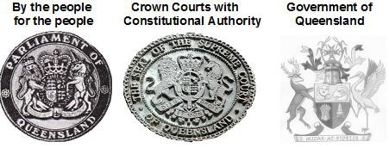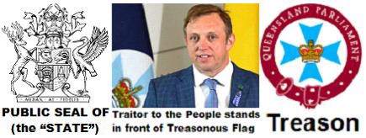
The Peoples Queensland as an Original State
as part of the Commonwealth at its
establishment.

Separation of Powers

Treason from within

Only Political Parties (Not the People) changed the
definition of Queensland in 1985 and created
their Queensland to the status to their
sovereign, independent and federal nation.
No Crown and Constitutional Authority
Writing on paper, we are fighting the PEN.

Page 2 of 5

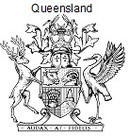
Political Parties Queensland to the status of a
sovereign, independent and federal nation.
They had to remove the Letters Patent 29th October 1900,
Crown and Constitutional Authority
from the State Governor to give Royal assent.
This was and still is
High Treason

Political Parties Queensland Acts tell us
all Acts from the Australia Acts forward are only
purported Acts with purported enactments,

All Acts are created within their Political Party Private,

Queensland Parliament,

Private Acts not to affect rights of others,

None of these Acts have Crown and Constitutional
Authority, therefore NO Royal assent.

Treason Seal
Local Government Act 1993 No.70
PART 3—INTERPRETATION
˙Definitions
4. In this Act—
“local government” means a local government established under this Act;
© The State of Queensland 1993
Only Private Acts can be copyrighted ©
Treason Seal
Local Government Act 2009 Act No.17
© State of Queensland 2009
Only Private Acts can be copyrighted ©
Page 3 of 5

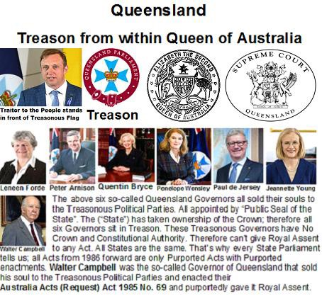
All these Political Party Queensland Acts
are extortion rackets using Treason.

I _ _ _ _ _ _ _ _ _ _ _ _ _ _ _ _ _ _ _ _ _ _ _ _ _ _ _ _ _ _ _ _ _ _ _ _ _
have transferred the guilt of knowledge of Treason to you

_ _ _ _ _ _ _ _ _ _ _ _ _ _ _ _ _ _ _ _ _ _ _ _ _ _ _ _ _ _ _ _ _ _ _ _ _

and to your heirs and successors.
Political Parties are the Republic
In 1999 we voted all the Political Parties and their Republic
Acts OUT and voted to stay as a Constitutional Monarchy

Page 4 of 5

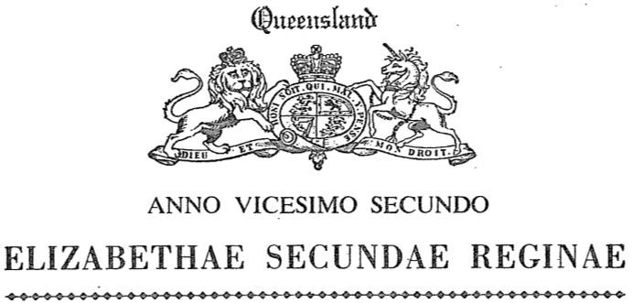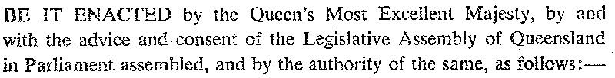
Queensland

CRIMINAL CODE ACT 1899 Punishment in special cases

CRIMINAL CODE ACT 1899
(63 Vic. No. 9)
An Act to Establish a Code of Criminal Law
(as amended)

Establishment of Code—Schedule 1
2.(1) On and from 1 January 1901, the provisions contained in the Code
of Criminal Law set forth in Schedule 1 (“the Code”) shall be the law of
Queensland with respect to the several matters therein dealt with.

BEFORE being CRIMINALLY AND FRAUDULENTLY SEALED with the Corporate
Public Seal of (the “State”) AND COPYRIGHTED © State of Queensland,
the Criminal Code Act 1899 [63 Vic. No. 9] as amended to 1934 [26 Geo.V. No.11],
included the following:-

Punishment in special cases

˙Public seals etc.
1. If the thing forged—
(a) purports to be, or is intended by the offender to be understood to
be or to be used as, the great seal of the United Kingdom or of
Queensland, or Her Majesty’s privy seal, or any privy signet of
Her Majesty, or Her Majesty’s royal sign manual, or the seal of
the Governor, or any public seal lawfully appointed to be used for
authenticating an act of state in any part of Her Majesty’s
dominions; or

(b) is a document having on it or affixed to it any such seal, signet, or
sign manual, or anything which purports to be, or is intended by
the offender to be understood to be, any such seal, signet, or sign
manual;

the offender is liable to imprisonment with hard labour for life.

Page 5 of 5

