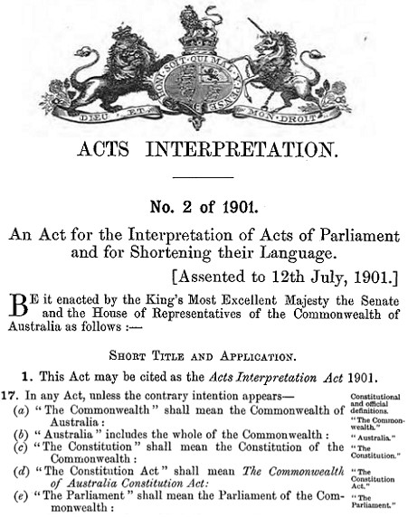
Changed Constitutional Definitions
Constitutional definitions went from this

Our Commonwealth of Australia Constitution Act
is a Common Law of England Contract and
holds all rights known to man.
_________________________________________________________

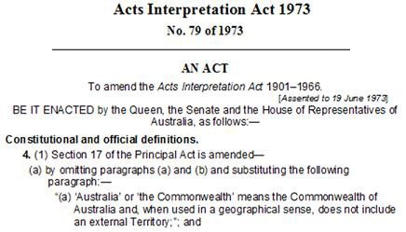
To this Treason
This Act was done while sitting within the walls of OUR Parliament

The above enacting Manner and Form has No Crown and Constitutional Authority.
The Crown and Constitutional Authority was removed in 1960 to enable Treasonous
Political Parties to create their private Corporation purportedly outside Our Primary
Law, Commonwealth of Australia Constitution Act 1901 as Proclaimed and Gazetted.
In 1960 the Politicians took ownership of the Governor-General and Commander in
Chief. This changed Our Primary Law as in Section 61 the Governor-General is the
Queens Representative. Therefore the Treasonous Politicians own and control the
purported Governor-General whom/which has lost the Authority to give Royal
Assent.
Section 58 of Our Primary Law dictates that all Acts must receive Royal Assent.
When Parliament has passed Bills they go to the Governor-Generals Office to get
Royal Assent. That involves Placing The Royal Coat of Arms and the Royal enacting
Manner and Form on the Bill which becomes an Act with Royal Assent.

Acts Interpretation Act 1973 No 79 changed the Constitutional and official definitions
creating their own Abstract Australia or Commonwealth means the Commonwealth
of Australia in Geographical Sense, outside Our Commonwealth of Australia
Constitution Act 1901 as Proclaimed and Gazetted.

in Geographical Sense,

Oxford Dictionary
geographical • adj. of or relating to geography.

geography • n the study of the physical features of the earth and of human activity
as it relates to these.

sense •n. a faculty by which the body perceives an external stimulus; one of the
faculties of sight, smell, hearing, taste, and touch (one's senses) one's sanity.

By these Treasonous Political Parties which are NOT within Our Primary Law,
Commonwealth of Australia Constitution Act 1901 as Proclaimed and Gazetted have
copyrighted © the above Constitution.

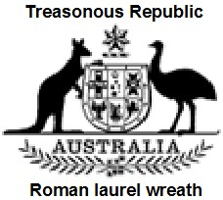
Commonwealth of Australia Constitution Act
An Act to constitute the Commonwealth of Australia
[9th July 1900]
© Copyrighted to their definition of their Commonwealth of Australia.

Total Fraud

This cloned Our Commonwealth of Australia Constitution Act under their changed
Constitutional definitions of Commonwealth of Australia.

Australian Electoral Act 1973 created Elections to their changed Constitutional
Definitions of Australia.

Australian Citizenship Act 1973 created abstract entities that swear their Oath to the
Political Parties Queen of Australia.

Family Court of Australia Act 1975 under Treasonous Political Parties changed
Constitutional Definitions of Australia.

Federal Court of Australia Act 1976 under Treasonous Political Parties changed
Constitutional Definitions of Australia.

Australian Federal Police Act removed the Commonwealth Police Act = changed
Constitutional Definitions of Australia.

High Court of Australia 1979 under Treasonous Political Parties changed
Constitutional Definitions of Australia.

All Acts from 1973 forward are enacted to the Queen of Australia. No Crown and
Constitutional Authority. All sitting in Treason.

The Contrary intention has never appeared to this day.

From this time forward 1973 all Commonwealth personal swear their Oath to the
Treasonous Political Parties abstract Queen of Australia.
After the Australian Citizenship Act creating all as abstract entities swearing their
Oaths to the Treasonous Political Parties abstract Queen of Australia.

In the 1988 Constitutional Commission, Bill No 1, it was stated that we needed that
there must be a Referendum for the Queen of Australia.

Also Bill No 2, another Referendum was needed for the Senate and Members of the
House of representatives to swear their Oath to the Queen of Australia.

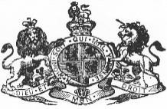

Commonwealth of Australia Constitution Act 1901 as Proclaimed and Gazetted.

Part II – The Senate
7 The Senate
The Senate shall be composed of senators for each State, directly
chosen by the people of the State, voting, until the Parliament otherwise
provides, as one electorate. NOT BY POLITICAL PARTIES

Part III – The House of Representatives
24 Constitution of House of Representatives
The House of Representatives shall be composed of members directly
chosen by the people of the Commonwealth, and the number of such
members shall be, as nearly as practicable, twice the number of the
senators. NOT BY POLITICAL PARTIES

In 1999 we voted all the Political Party Republic Acts OUT.

Political Party Treason

A Federal Referendum of the people is an explicitly binding Act on
all Political Parties, Australian Governments. When Australian
Governments and Political Parties don’t listen to Referendums they
enact “TREASON” upon themselves.

