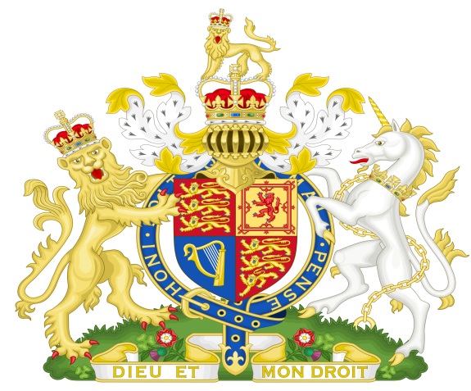

Statement of Evidence to Obtain the Attached Warrant and Place
The named Offender in Custody Pending Trial
by Grand Jury of his or her piers

- The said Offender is a member of an Unlawful Political Party operating
under the Australia Act 1986 without Lawful Authority.

- The Australia Act 1986 was not put to The People by Referendum
under 128 of Our Commonwealth Constitution Act 1900 UK and
The Commonwealth Constitution 1901 and so is Unlawful.

- There could be no conferral of the States as every State had
REMOVED their original Constitutions and REPLACED them with
Unlawful Constitutions contrary to 106 of the Commonwealth
Constitution Act 1900 UK and the Commonwealth Constitution 1901.

- Pursuant to Clause 7 of Our Constitution there was no authority
granted by Section 51 ss xxxviii of the Commonwealth Constitution
1900 UK or our Commonwealth Constitution 1901
Ref Page 651 Q & G (b).

- The said Political Parties created the Queen of Australia using the
Australia Act 1986 and declared the Commonwealth as a Sovereign
Independent and Federal Nation without compliance with 128 of
The Commonwealth Constitution Act 1900 UK and The
Commonwealth Constitution 1901.

- The Political Parties that the OFFENDERS belong to were Privy to and
operated under the Letters Patent proclaimed by BOB HAWKS
(PRIME MINISTER) on the 24th of August 1984 by a Fraudulent
command of the Reigning Monarch of this country,
therefore waging war on the Monarch and Her People.

- In 2020 the Offenders CONSPIRED TOGETHER to form a
NATIONAL CABINET without consent of The People by 128 of the
Commonwealth Constitution Act 1900 UK and
Our Commonwealth Constitution 1901.

- This NATIONAL CABINET took control of The People who are
The Commonwealth, and put them into SLAVERY BY
DICTATORIAL RULE contrary to 268 ss 10, 11 and 12
of the Commonwealth Crimes Act.

- The NATIONAL CABINET set aside the Commonwealth
Constitution Act 1900 UK and the Commonwealth Constitution 1901
again WAGING WAR ON THE Crown and The People who are
The Commonwealth of Australia contrary to the 1999 Referendum at
which The People voted to retain the Crown and
Our Lawful Constitution.

- The OFFENDERS were Warned of THEIR CRIMES
on the 7th of January 2019 when a Commonwealth Public
Official who Seized the Three Tiers of The lawful Federal
Parliament the Unlawful GREEN POLITICAL PARTY
CONSTITUTION all of THEIR PURPORTED ACTS
and STATUTES and all of the Assets of The People and
Crown, The People who are The Commonwealth now Hold
all of the above in Adverse Possession under the Crown
until the POLITICAL PARTIES prove otherwise –
Simply THEY CAN NOT.

- Lawful Documents explaining the above Seizure were
served on Scott Morrison The Federal Parliament and on
the House of Lords England by email and Registered Post.

- The House of Lords per Lord Fowler, the Lord Speaker
Accepted the Documents and sent a return email stating
they would look into the situation.

- On the 10th of December 2021 The People through Velvet
Revolution Served The Lawful Moratorium on every
Parliament House in the Commonwealth of Australia, every
Governor and The Governor-General ordering them to
comply by the 18th of December 2021 to The Will of The
People who are the Commonwealth.

- On the 18th of December 2021 Notices were placed on all Public
Building belonging to The People who are the Commonwealth,
ordering all POLITICIANS and members of the
POLITICAL PARTIES to remove themselves from Our Buildings.

Dated:

Signature

_________________________

Name

__________________________

Witness

