Treasonous Political Parties changed Constitutional Definitions without a Referendum
By the Political Parties changing the Constitutional and officials definitions, they have changed the Commonwealth of Australia Constitution Act 1901 consisting of its Preamble, Clauses 1 to 9 and the Schedule without a Referendum = Treason.
The Political Parties owned the Governor-General and Commander-in-Chief since 1960 so they could do what they want, when they want. They make their abstract Australia as big and as small as they want. This is made very clear by their Seas
and Submerged Lands Act 1973. Their abstract "Australia" abstract "Commonwealth" means the abstract "Commonwealth of Australia" is nothing but writing on a piece of paper, one big com job.

Forced enrolment and vote is a criminal action by the Corporate Political Parties.
The original Electoral Act No 17 of 1918 was 62 pages.
So called, same Electoral Act 15 February 2021 is 661 pages long.

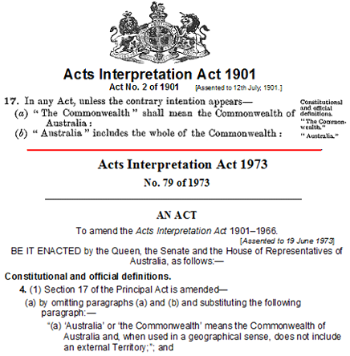
Acts Interpretation Act 1973 No 79 is a private Act, No Crown and Constitutional Authority. The enacting manner and form, removed Crown Authority of all Commonwealth Acts from the very first Act of 1973. Therefore all Commonwealth Acts are enacted to the abstract Queen of Australia. The Political Parties created the Australian Electoral Office Act 1973 No. 87 of 1973 using their Treasonous changed Constitutional Definitions of their Commonwealth and Australia. All Political Parties have to go to the Political Parties Treasonous Commonwealth Electoral Act and create a Party Constitution within that system to get their names and members' names on the Ballot Paper for Elections and Referendums = Treason.
This puts all Political Parties and Independents under these Treasonous Definitions. All this is for the Treasonous Political Parties, Status of their Commonwealth of Australia as a sovereign, independent and federal nation = Treason

Members of Political Parties, each under their own Party’s Constitution and policies,
have deceived us and our Constitutional Sovereign and Monarch, by creating
under a progressive evolutionary process, Corporations that control all entities inside
Parliaments, Governments and Courts “of Australia”, with NO Separation of Powers
and with purported “Governor-Generals” and “Governors” under their control also.

High Treason by Governor-General and Commander-in-Chief and all State Governors

Where is and was the Judiciary ??
The Guardians of the Constitutions

Commonwealth of Australia Constitution Act 1901 is NOT a tool to be wielded for Political Party expediency. It is the Supreme law of the Commonwealth of Australia. The Governor-General and State Governors in conjunction with the High Court at Chapter 3, Judiciary Act No 6 of 1903 are the Constitutional Commonwealth and State Guardians to take care that it is followed, NOT outmanoeuvred by Political Parties. The Federal and State Parliaments are not sovereign bodies; they are legislatures with limited powers, and any law which they attempt to pass in excess of those powers is no law at all, it is simply a nullity, entitled to no obedience.

The Treasonous Guardians of the Constitutions sold their souls and joined the Political Parties sovereign, independent and federal nation
High Treason

