Mr David Morris MP  
Shadow Minister for Local Government  
Parliament House  
Melbourne

Dear Mr. Morris,

# Proposed Local Government Act 2018

I am writing about an email written by Alan Manson where he claimed **that the Local Government Act 1989 is unlawful**, as published on this website:

<https://larryhannigan.com/government-local/14-update-1-local-govt-assoc-2018-campaign/>

I would like to bring the following points to your attention that are of concern to me about this matter that both the Minister and Mr. Manson have made.

1. “**Councils are currently constituted as bodies corporate**…” An incorporated body (or corporation) cannot perform the functions of a government under the Westminster system of government that Australia operates under, as a corporation cannot contain two houses of parliament within it, nor does it have a Treasury or regal representation; meaning a person appointed by Elizabeth II, by the Grace of God of the United Kingdom of Great Britain and Northern Ireland and of Her other Realms and Territories Queen, Head of the Commonwealth, Defender of the Faith.
2. **Institutions such as “The Parliament of Victoria; the Victorian Police; the Supreme Court; schools and hospitals** have all been transformed from being agencies that were originally funded by the government but have since been transformed into independent corporations so as to make profits from Victorians using their services.
3. **The Constitution of Australia requires the voters of Australia to approve any changes to the Constitution such as a government proposing to legislate for councils to become “…*a distinct and essential tier of government*”**. It is clear that no referendum has occurred to allow this to happen.  
     
   Mr. Manson’s evidence indicates that in 1989, the Victorian parliament and Victoria’s Governor allowed the **Local Government Act 1989** Bill to be passed into law despite it breaking the requirements of the Constitution of Australia 1900 referred to above. He states that this act committed by those concerned “…*in itself is a crime*”.

I don’t need to repeat Mr. Manson’s claims in his email to reinforce my concerns to you about this matter; however my purpose for bringing this to your attention is to request that you give me the Opposition’s position to the following questions that I have also asked the Minister, citing Mr. Manson’s earlier posting at <https://larryhannigan.com/government-state/13-victorian-local-government-act-2018-submissions/> which contains extracts he produced from the proposed Act.

My questions relating to the proposed **Local Government Act 2018** Bill are:

1. Does the Opposition support the concept to make municipal councils an “Authority” as stated in the proposed legislation in 151(2)(b) and reproduced below?

By making each local council throughout Victoria an “Authority”, this means that anyone affected by a council’s law or decision has no means to appeal its effect on them.

Given the high level of corruption, bullying and the politicisation of local councils, do you consider the upgrading of councils to “Authority” status is a good thing for the community or not? If “yes”, can you please explain why?

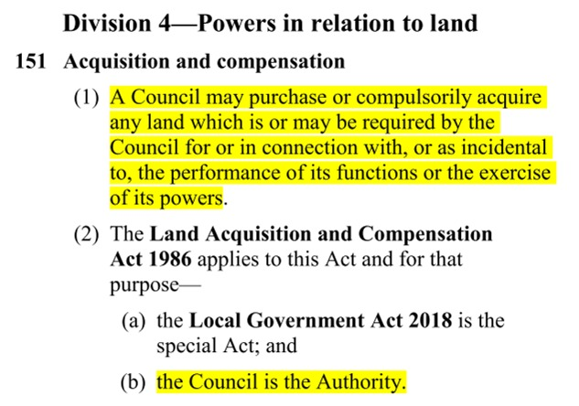

1. From what Mr. Manson wrote about the new “Local Laws”, he claimed that ALL MUNICIPAL COUNCILS within Victoria as being “…a distinct and essential tier of government” will be able to make LAWS that contravene the Constitution of Australia 1900, which says only State parliaments are allowed to make “laws”; and the names of the States are defined in the Constitution [here](http://www8.austlii.edu.au/cgi-bin/viewdoc/au/legis/cth/consol_act/coaca430/s6.html):. The point here is that Local Councils cannot be considered a State under the Constitution:

[QUOTE 1](http://www8.austlii.edu.au/cgi-bin/viewdoc/au/legis/cth/consol_act/coaca430/s109.html):

Section 109 of the Constitution of Australia provides that: When **a law of a State** is **inconsistent** with a law of the Commonwealth, the latter shall prevail, and the former shall, to the extent of the inconsistency, be **invalid**.

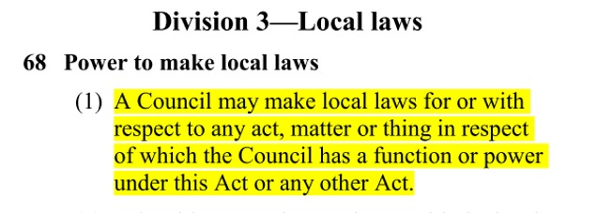

In this context, "**a law of a State**" could be the Local Government Act (1989 or 2018) that is required to be consistent with the Law of the Constitution of Australia. If it is "**inconsistent**" in any way, it then becomes "**invalid**" and should NOT be made into 'law'.

[Quote 2](http://classic.austlii.edu.au/au/legis/cth/consol_act/coaca430/s108.html):

**COMMONWEALTH OF AUSTRALIA CONSTITUTION ACT - SECT 108**

**Saving of State laws**

**Every law in force in a Colony which has become or becomes a State**, and relating to any matter within the powers of the Parliament of the Commonwealth, shall, **subject to this Constitution**, continue in force in the State; and, until provision is made in that behalf by the Parliament of the Commonwealth, the Parliament of the State shall have such powers of alteration and of repeal in respect of any such law as the Parliament of the Colony had until the Colony became a State.

As no law can be found in the Constitution of Australia that permits any State Government to empower municipal council to create “Local Laws”, I would be very interested for you to explain the Constitutional basis that the Opposition might support the very high status of “Authority” being imposed upon municipal councils for them to make “Local Laws”?

1. ALL MUNICIPAL COUNCILS within Victoria will be able to enforce these laws using “authorised officers” — the police;

In Clause 327 (below), the Bill’s intended empowerment provision is for councils to make “Local Laws” and to require the police to “enforce that provision” – which is mind-boggling; because no one in the community knows what laws they will enact, and there has been no provision made for those affected by these new laws to appeal them!

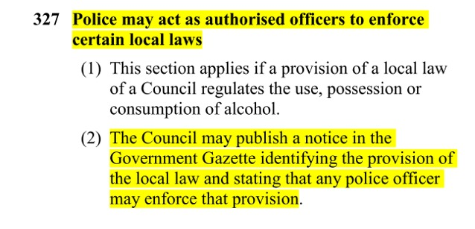

Therefore, I require you to indicate whether the Opposition would approve of the police being called to ratepayers premises to enforce “Local Laws” that are unknown at this time?

1. “Authorised officers” will be able to enter a person’s property or home or business (a “building”);

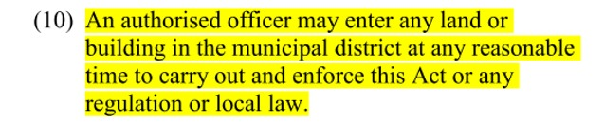

The proposed Bill provides the legal right for a Council to empower “an authorised officer” to “enter any land or building” (presumably a person’s home or business) “to carry out and enforce this Act…or local law”

Therefore, I require to know the Opposition’s perspective as to whether this Bill disregards each Victorian’s human right to Privacy by Council’s “Authorised officers” and “police” when entering private property. The *Victorian Charter of Human Rights and Responsibilities Act 2006* guarantees every Victorian their right to not have their personal privacy interfered with – and this provision includes Council’s “Authorised officers”!

Similarly, there are also High Court of Australia rulings that remain valid today that respect trespassing laws on private property, which this legislation overrides. For instance: [High Court of Australia PLENTY v DILLON [1991] 171 CLR 635 F.C. 91/004](http://www.cirnow.com.au/trespass-and-your-rights/)

In support of this claim, below is an extract taken from the [Victorian Charter of Human Rights and Responsibilities Act 2006](http://www.austlii.edu.au/cgi-bin/viewdoc/au/legis/vic/consol_act/cohrara2006433/s13.html?context=1;query=sect%2013;mask_path=au/legis/vic/consol_act/cohrara2006433) that it appears the Minister was not aware of when drafting this Bill:

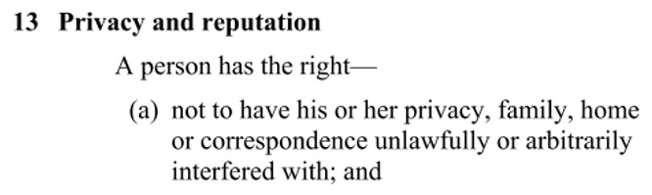

This overriding of ‘Trespass’ and ‘Human Rights’ laws in the Minister’s Local Government Act 2018 makes this Bill unlawful. I feel it is for this reason alone that this Bill must be scrapped, but what does the Opposition think about this, Mr. Morris?

1. The council will impose “environmental improvements” required to be undertaken by the landowner.

It seems from Clause 134 (below) that local councils will be required by the Minister to *offer* certain landowners of “rateable land” the opportunity to become involved in improving the “sustainability”of their “existing building(s)” in regards to “energy, water” services:

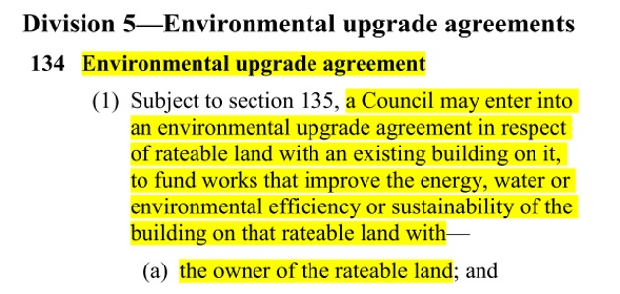

Therefore, I require the Opposition to answer me the following questions:

* 1. If a landowner chooses to decline such an agreement, would the Opposition support the **essential services of electricity, gas and water** be allowed to remain connected to the premises or not?
  2. If the answer to the above question is “No”, does the Opposition support the house being deemed by the local council as ‘**Uninhabitable’**?
  3. If the answer to that question is “Yes”, what are the options that the occupants of that **business**, **house** or those in **a body corporate entity** might have towards obtaining other accommodation that does have “energy, water”?
  4. If a rural landowner currently living off-grid and using their own sources of “energy, water” declines having an EUA with their local council, would the Opposition support councils preventing such people from accessing their own “energy, water” sources – because of Climate Change policies –meaning, they will need to purchase Energy Efficiency Certificates to access these resources?

1. The environmental upgrade will affect both landowner and tenant;

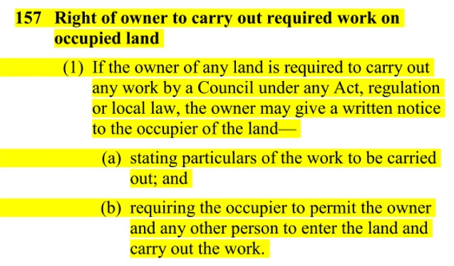

It appears from the foregoing clause that tenants will have few rights under this legislation, and may be evicted by their landlord or “authorised officers” if any upgrade work is to be performed.

Therefore, please explain to me if the Opposition endorses the eviction of tenants in this Bill.

1. Future works to be undertaken at the landowner’s costs related to the **Victorian Energy Efficiency Target Act 2007** (VEET Scheme);

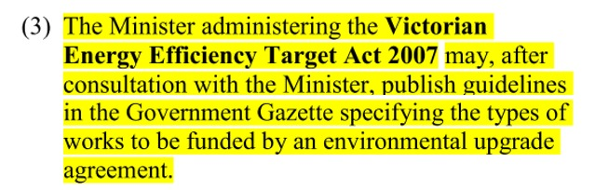

It is clear from the proposed legislation that the VEET Scheme is to be implemented by “Local Councils” who will make “local Laws” using “authorised officers” supported by “police” whenever necessary to enforce the requirements of this scheme. Can you confirm as Shadow Minister, what is the Opposition’s position on the implementation of Climate Change policies in respect of the foregoing statement?

1. If the landowner is unable to pay the accumulated costs associated with an EUA, one option is that the land involved will be “transferred” to the Council and the Council will become the new owner of the land, as shown in the extract that follows.

Therefore, could you confirm for me if the Opposition supports the above action or not?

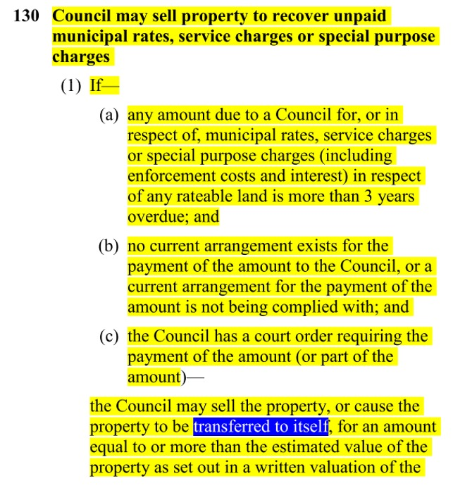

1. If the landowner fails to undertake the specified “works” required by the Council, the Bill’s extract (below) indicates that the Council may appoint a contractor to do the works prescribed, and that Council will impose charges upon the landowner for the work performed:

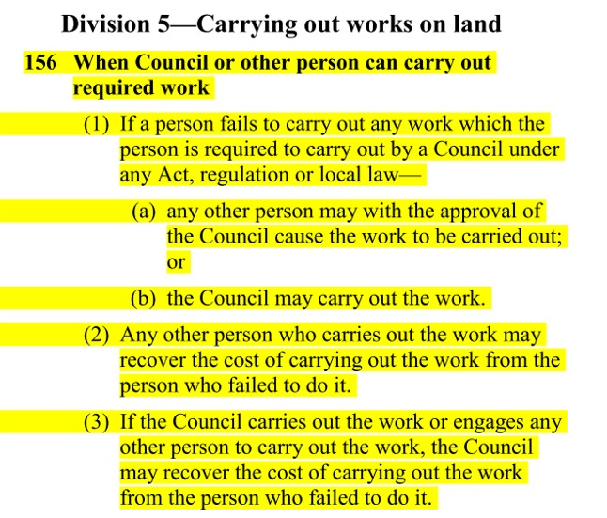

Therefore, I require knowing the Opposition’s response to the following questions:

* 1. If a landowner fails to undertake any prescribed “work” such as an “Environmental Upgrade Agreement”, does the Opposition support a process where councils will appoint “any other person” (such as a council-approved contractor) and be given the right to enter the landowner’s property to perform the work required without the landowner’s consent to do so?
  2. Does the Opposition support any Council adding on additional fees and charges for the landowner to pay in their process of “recovering the cost to carry out the work”– regardless of whether the landowner is potentially unable to pay the costs or not?
  3. In the event of a landowner being unable to make such payments, does the Opposition support the intention of this legislation to force private landowners into a position where the council will then seize the property by “transferring it to itself”?

1. In the extract from the Bill shown below, it indicates that after the foregoing events have taken place, the former landowner will be assigned “market value” of their former property minus any encumbrances such as a mortgage plus ALL of the council’s “charges” associated with the work of transferring the property.

Can you confirm or deny that the Opposition would support the seizing of private land as stated in this Bill and that it supports the process of providing the former landowners with “market value” of their land minus council fees and charges?

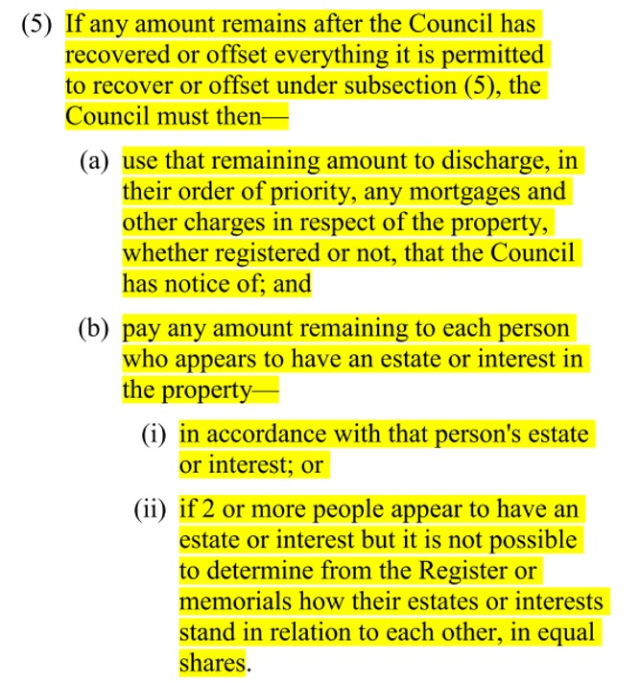

In addition to the above questions, can the Opposition provide full assurance that a landowner/ mortgagee who has their land “transferred to the Council” be assured that the lender (i.e. the Bank) will fully discharge their mortgage and that the landowner will not be left with an undischarged mortgage and no land and unable to appeal the outcome because the Council is an “Authority”?

Is the Opposition aware whether a Council (as a third party) is able to intervene between a mortgagee and his or her lender to discharge a mortgage and in doing so transfer the property to the Council – a corporation? In other words, is such a financial intervention by a third party legal, and if so can you please advise me under what law is that permitted

1. If the property is being leased (prior to it being “transferred” to the Council and then sold) the tenant will have to vacate the property, as stated in the Act below:

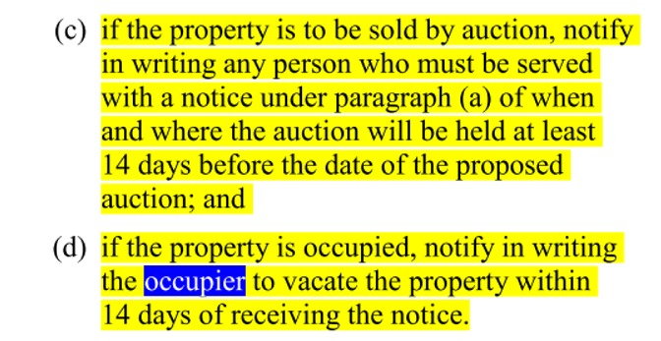

In such an event, many landowners and tenants will not only find themselves looking for rental accommodation, but will only receive “market value” as determined by a “valuer”(Clause 130) while the land having been “transferred” to the council’s corporation now becomes its legal owner [130 (8)].

I require the Opposition to state what their position is if councils use their new found “Authority” in which to devise *corrupt* ways to acquire owner-occupier land unlawfully. What will councils do with the land and its improvements afterwards?

* Would the Opposition approve such properties being used as temporary housing for migrants or homeless people?
* What would the Opposition suggest could happen to the displaced former owners if they can’t find any rental accommodation?
* Has the Opposition considered what would be the social impacts of this Bill and does this Bill meet **Victoria’s Charter of Human Rights and Responsibilities Act 2006** when viewed in this context?

I require you to answer the above questions, Mr. Morris!

### Comments

I am aware that politicians have a tendency to remain silent on issues they prefer to not discuss.

If you choose to take this course of action in regards to my requests for answers, you will leave me no alternative but to conclude that in doing so you might incriminate yourself.

Therefore, I am offering you the period of **7 days** from the date on this document in which to respond to ALL the questions contained in this letter.

If you fail to respond within the allocated time, I will deem that you (together with those in the Opposition in the Victorian Parliament) are conspiring to defraud Victorians out of their homes and businesses by supporting this draft legislation in the Parliament, and that you and other members of the Opposition will use your best endeavours to make the Bill become law.

This means that you and your Opposition colleagues will be guilty of committing the [criminal act of Treason](http://www6.austlii.edu.au/cgi-bin/viewdoc/au/legis/vic/consol_act/ca195882/s9a.html), because you have failed to create legislation that is in accordance with the Constitution of Australia, together with the [Victorian Charter of Human Rights and Responsibility Act 2006](http://www8.austlii.edu.au/cgi-bin/viewdb/au/legis/vic/consol_act/cohrara2006433/).

Kindly email me your response to the address indicated below avoid any delays in me receiving your correspondence.

Thank you Mr. Morris.