**Submission**

**Local Government Bill – Exposure Draft**

|  |  |
| --- | --- |
| **Name:** |  |
| **Address:** |  |

If you work in an organisation or council, please provide the following information:

|  |  |
| --- | --- |
| **Organisation or council name** |  |
| **Position** |  |
| **Are you providing this submission on behalf of the organisation or council?** |  |

General Comments to Part 6 — the Corporate Structure

The basis of my concerns about the proposed legislation is that it allows councils throughout Victoria to have a corporate structure (in which to make profits for its shareholders) and to have extreme powers as an “Authority” by which to create and enforce its own laws. Referring to such commercial organisations as ‘Local Government’ is inconsistent with the Australian Commonwealth Constitution 1900, and can best be described as an oxymoron.

Any ‘government’ properly structured under the Westminster system requires the following structure to be adhered to if it is to be termed a *de jure* government. In other words:

* **A ‘government’ must have a regal representative**. This happens with Australia’s Governor General and the Governor of Victoria in our *two-tier* Commonwealth and State parliaments. On the contrary, no such structure exists in any local council.
* **A ‘government’ must have a parliament.** This happens in the Upper and Lower houses of parliament in our Commonwealth and State parliaments. On the contrary, no such structure exists in any local council.
* **A ‘government’ must adhere to its Constitution.** This happens in our Commonwealth and State parliaments. On the contrary, no council has a constitution, possibly only its Memorandum and Articles of Association; therefore councils cannot be termed ‘Local Government’.

In addition to this, the Australian Commonwealth Constitution 1900 only allows for TWO levels of government—these being the Federal (highest) and the various State Governments (lowest) throughout Australia. There is no provision made within the Constitution where the Federal or State parliaments have the power to establish a “third tier of government” without the permission of the people of Australia allowing this to happen via a Federal Referendum.

Section 128 of the Australian Commonwealth Constitution 1900 describes certain requirements that must be followed in order for changes to the Constitution to be approved. If the people agree to a new level of government being established through a referendum, then changes to the Constitution would have to be made to accommodate this need. None of this has happened.

In the table below (that has been extracted from the Australian Electoral Commission’s website[1]),it can be seen that there have been two attempts by the Federal Government in the past to “**recognise Local Government**” using referendums, but in both instances they have failed. Therefore, these referendums make section 74A(1) of the existing Victorian Constitution Act 1975 unconstitutional.

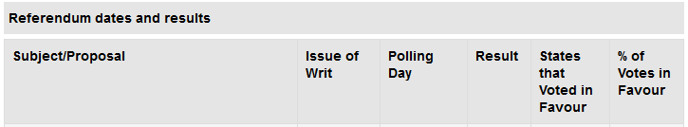

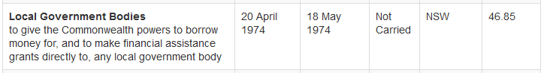

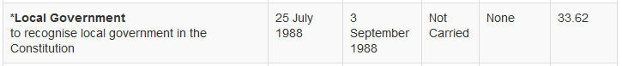

When the Victorian Constitution Act 1975 became law, this meant that ALL parliamentarians since 1988 have illegally legitimised councils against the will of the people and against the Australian Commonwealth Constitution 1900.

With Local Government being considered the “third tier of government” as defined in the Draft legislation, this claim contradicts the Australian Commonwealth Constitution 1900, which makes the statement that follows false:[2]

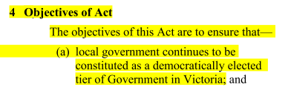

When the referendum results (shown previously) are compared to this Draft legislation, the conclusion can be drawn that it should be thrown out of parliament due to its illegality—on this basis alone.

With this claim firmly established, I would like to highlight some further points made in the Draft legislation that are also highly questionable.

Council being established as an “Authority”

In the image below taken from page 131 of the draft legislation, it can be seen in (1) that councils will be able to “acquire any land” in “the performance of its functions”. This is quite a frightening statement.

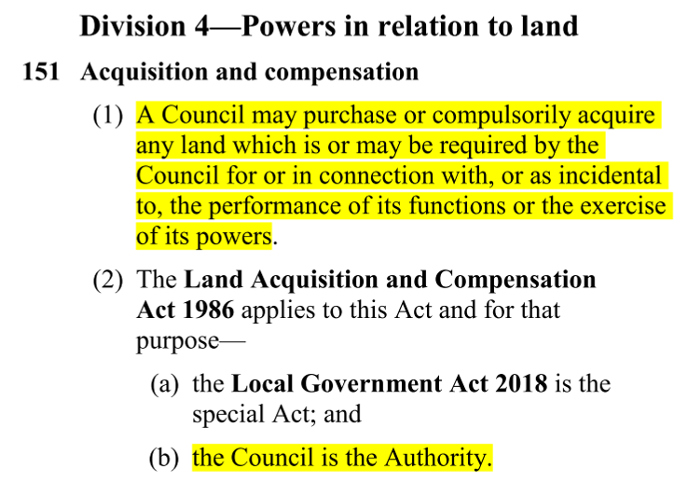

Also in this clause is the statement “the Council is the Authority”. The legal definition of the word “Authority” is shown below:

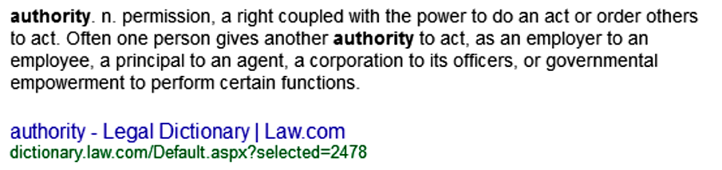

For a corporation to be given such immense powers as being an “Authority” — such power will permit any Victorian council to effectively become a law unto itself. This power will provide little or no recourse for anyone impacted by a council’s adverse decisions against them or their property.

I make this claim regarding a council’s power to acquire land, as shown in the partial extract reproduced below:

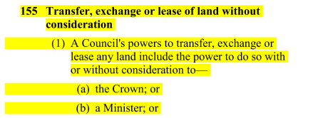

Please notice that if land is “exchanged” from the former private landowner to the council for say the non-payment of rates or fines, neither “the Crown” (meaning the State Government) or the Minister for Local Government can intervene “without consideration”.

Therefore, I feel that given the past history of municipal councils becoming corrupt within themselves (as a body of people requiring sacking) or as certain individuals within it becoming corrupt[3], it is of immense concern that the Victorian government is considering bestowing these draconian powers on councils that have such a poor record for being transparent to the ratepayers and for conducting council business in a fit and proper manner. To illustrate the level of corruption that extends throughout much of Australia, The NSW Independent Commission Against Corruption (ICAC) [4] supports this claim in the highlighted statement below:

EXAMPLE:

Misconduct and corrupt behaviours in local government can be perpetrated by the councillors, the leadership team of the council, the staff against the interests of the council, external parties outside of the council, and/or a combination of the four groups. The question of why does this happen and in what circumstances can it happen, can be an imponderable and potentially unanswerable question. There can be multiple answers, with each of them specific to the organisational culture of the councils in which the behaviours have occurred, rather than having some type of forecasting tool which can predict incidences of corruption...The Independent Commission Against Corruption (ICAC 1998) reviewed the literature pertaining to corruption and misconduct, and stated that there are inherent risk factors which can: (1) enable or optimise corruption and misconduct and (2) aid in the perpetration of the corruption and misconduct. .

In the same document (Footnote 4) on page 36 and 37, the following statement refers to a “number of reviews” that have been conducted relating to corruption occurring in Victorian councils:

There have been a number of reviews into misuse of statutory powers, maladministration, malfeasance and dishonesty in Victoria, which directly impacts upon local government governance. These were complemented by similar investigations in New South Wales and Queensland.

Another highly questionable aspect of council’s legality as a “tier of government” relates to their unusual status of being termed a “State” with the inference of being a “State of Australia” for the purpose of appearing to be consistent with the Australian Commonwealth Constitution 1900 in a somewhat abstract form.

Whether it is for the purposes of making monetary gains on the sale of land to achieve significantly reduced GST payments[5], or to be legally entitled to levy rates and fines on ratepayers as the Commissioner of the Australian Taxation Office states in the extract below from the Australian Taxation Office[6] the question is—who really knows what goes on in these areas of corporatised government when things don’t appear as they should?

But in either option, one can’t help question WHY a local council should be deemed “a State”—if not for ulterior purposes.

QUOTE from the Australian Taxation Office:

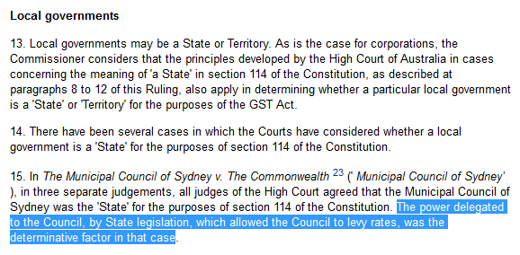



It must be remembered that ‘local councils’ (as they currently exist) are corporations that have been established to make their owners/directors/shareholders large profits. Under the Australian Commonwealth Constitution 1900, operating such an entity in the form of “government” is illegal; but by establishing local councils as ‘States of Australia’[7] (which opposes the Constitution), it seems such entities have become legally entitled to levy rates and issue fines as any “State” does under the Constitution; however the Constitution still regards today’s council’s activities as illegal. So the question is—under ‘what constitution’ is the Victorian public being governed that allows local councils to become separate States within Victoria?

The Enforcement of new “Local Laws”

In Division 3—Local Laws; subsection 68—Power to Make Local Laws (page 62 onwards), the draft legislation clearly states that the new councils will have power to make ‘Local Laws’, which will be different to by-laws.

In subsection **130 Council may sell property to recover unpaid municipal rates, service charges or special purpose charges**, it says in (1);

QUOTE:

“...the Council may sell the property, or cause the property to be transferred to itself, for an amount equal to or more than the estimated value of the property as set out in a written valuation of the property by a valuer that was made not more than 6 months before the date of the sale or transfer.”

With the power available that enables councils to “...cause the property to be transferred to itself”, situations could emerge where a corrupt council imposes a significant amount of work upon a privately owned property that the owner cannot financially afford to have done. As this inability to comply with council’s directions will breach the council’s new ‘local laws’, the council then arranges the work to be done through an external contractor and the council then bills the landowner for the work. As the landowner still cannot pay the costs, the land is transferred to the council (the new owner) and the former landowner is given the “written valuation” amount in return with any costs, fees and interest being deducted. In some cases, such action could effectively see people being evicted from their homes.

Whether the scenario presented above might be considered extreme or not, the point here is that there is nothing in the legislation to protect private property owners or tenants from the actions of corrupt council activities.

Comments about Draft Statement of Compatibility-Local Government Exposure Draft Bill

Human Rights Considerations

On page 2 of this document, the following statement is reproduced. The points of concern are shown highlighted:

“...For example, Part 3 of the Bill empowers councils to make local laws in relation to any mater for which the Council has a function or power and Part 5 of the Bill empowers councils to levy rates and charges on rateable land. While the Bill enables councils to exercise these defined powers, the Bill itself does not establish the local laws or levy rates. When exercising these powers however, Councils are required to consider the human rights set out in the charter in accordance with their obligations under that Act.

The Bill clarifies this in relation to local laws by providing that a local law must not be inconsistent with the Charter.”

On page 6 of this document, the following statement is made.

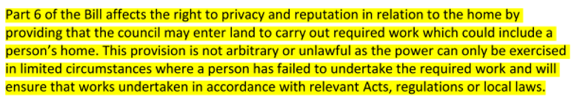

The statement above means that any council can authorise a person on behalf of the council to enter private property and a person’s own home without infringing their human rights.

Where the document says, “...the power can only be exercised in limited circumstances...” one wonders what these circumstances could be, given that any protections for Victorians against a corrupt council have not been provided for in the draft legislation.

In the Victorian legislation titled, *Charter of Human Rights and Responsibilities Act 2006[8]* it says this regarding a person’s right to privacy in his or her home.

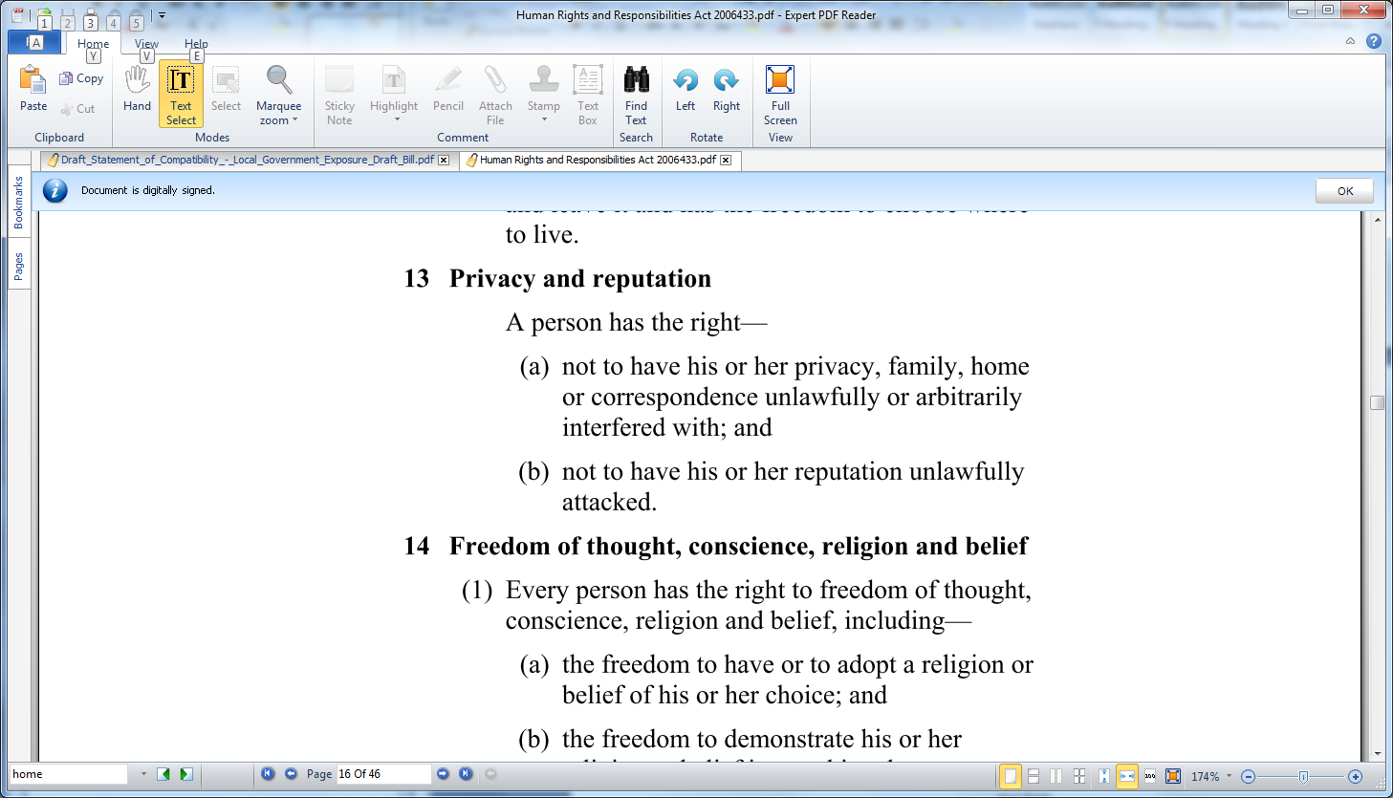

Yet the Compatibility document makes the above statements that contradict this legal right by saying in relation to council entering land or a person’s home that:

“This provision is not arbitrary or unlawful ...”

Therefore, if the Compatibility document is so flawed in respecting the human rights of Victorians in regards to personal privacy, it makes one wonder whether anything else written in this document can be trusted.

Review

The forgoing notes have proven that this draft legislation is not fit to be read in the parliament, because:

* TWO referendums in the past have demonstrated that the Australian people rejected the concept of local councils being recognised as ‘government’;
* These TWO referendum votes prove that Section 74A(1) of the Victorian Constitution Act 1975 is illegal and has been since its inception;
* The corporate structure of today’s municipal councils (termed the “third tier of government”) contravenes the structure of Westminster system of government as described in the Australian Commonwealth Constitution 1900;
* The Australian Commonwealth Constitution 1900 allows for only TWO levels of government. If THREE levels are required by the Australian people, then changes in the Constitution are needed. As there have been no changes to the Constitution since the last referendum in 1998, all local councils have been operating illegally as ‘Local Government’ since then.
* The Draft legislation plans to bestow upon all Victorian councils the right to become an “Authority”. This means possibly no person will be able to challenge any decisions made by any council regarding land matters given that neither “the Crown” (presumably the parliament or the Governor of Victoria) can intervene in matters involving the transfer, exchange or lease of land.
* The NSW Independent Commission Against Corruption (ICAC 1998) is recorded as having reviewed the literature pertaining to corruption and misconduct amongst councils, and stated that ***there are inherent risk factors in the existing structure of local councils which can: (1) enable or optimise corruption and misconduct and (2) aid in the perpetration of the corruption and misconduct***. If councils were to be given “Authority” status, how much more corruption could take place and how much damage would this do to many Victorians who either own or lease land throughout Victoria?
* Local Councils currently hold the legal status of being a “a State” for the purposes of avoiding GST payments to the ATO and to levy rates and fines, but does this mean they have used a back-door means by which to become legally entitled to perform these roles as a “third tier of government”? If so, then ‘what constitution’ allowed this to happen?
* The enforcement of new Local Laws by councils is likely to see private land ownership being “transferred” to local councils by their local laws not being adhered to by either the landowner or a tenant occupying the land. This means the Draft legislation will affect ALL landowners and tenants alike.
* The Draft legislation plainly contravenes the Victorian *Charter of Human Rights and Responsibilities Act 2006* by denying that homeowners have any rights to privacy where it states “...the power [to enter and possibly evict] can only be exercised in limited circumstances...” without the “limited circumstances” being explained.

With the above list of illegal actions by councils being exposed and the fact that this draft Bill is so flawed because it:

* Contravenes the Australian Commonwealth Constitution 1900 in several areas;
* Contravenes the Victorian Charter of Human Rights and Responsibilities Act 2006;

therefore, the Bill should be thrown out of the parliament.

DEMAND

Considering the foregoing evidence proves that **local councils today are illegitimate** and that **the Draft Local Government Act 2018 is inconsistent with the Australian Commonwealth Constitution 1900 and the Victorian Charter of Human Rights and Responsibilities Act**;

It is My Will that every honest politician in both houses of the Victorian Parliament should:

* NOT allow this Bill to be read in the Parliament;
* NOT allow a vote to proceed in the Parliament;
* NOT allow the Bill to be passed in the Parliament; without speaking up and condemning the Bill.

If parliamentarian’s voting on this Bill fail to comply with the above requirements, such an act will be considered a breach of the Commonwealth and State law and a betrayal towards the citizens of Victoria to whom they purportedly represent.

END

1. <http://www.aec.gov.au/Elections/referendums/Referendum_Dates_and_Results.htm>
2. Page 18; Local Government Bill Exposure Draft.pdf
3. <http://www.news.com.au/news/council-raided-in-corruption-probe/news-story/495426b5162691520a86b76487d2e895>
4. <https://www.iia.org.au/sf_docs/default-source/technical-resources/Corruption_and_misconduct_in_local_government.pdf?sfvrsn=0>
5. <http://www.mondaq.com/australia/x/170942/Local+Government+and+GST+a+simple+issue>
6. <http://law.ato.gov.au/atolaw/view.htm?docid=GST/GSTR20065/NAT/ATO/00001>
7. <https://corpau.blogspot.com.au/2015/09/melton-new-and-illegal-state-within.html?m=1>
8. <http://www6.austlii.edu.au/au/legis/vic/consol_act/cohrara2006433.pdf>